Vertically resolved particulate (zooplankton) biomass and size-structure across a continental shelf under the influence of a western boundary current

Hayden T. Schilling1,2, Jason D. Everett2,3, Amandine Schaeffer4,2, Peter Yates1,2, Mark E. Baird5, Iain M. Suthers1,2

1Sydney Institute of Marine Science, Chowder Bay Road, Mosman, New South Wales, Australia

2Centre for Marine Science & Innovation, UNSW Australia, Kensington, New South Wales, Australia

3Centre for Applications in Natural Resource Mathematics (CARM), School of Mathematics and Physics, University of Queensland, Brisbane, QLD, Australia

4School of Mathematics and Statistics, UNSW Australia, Kensington, New South Wales, Australia

5Commonwealth Scientific and Industrial Research Organisation, Castray Esplanade, Battery Point, Tasmania, Australia

Corresponding author: Hayden T. Schilling ([h.schilling@unsw.edu.au](mailto:h.schilling@unsw.edu.au))

Main text ≈ 8000 words, 1 Table, 9 Figures

Abstract

Continental shelves are the interface between society and the oceans, supporting over 90% of the world’s fisheries through highly productive ecosystems. Boundary currents drive oceanographic processes on many continental shelves, yet it is uncertain how boundary currents influence the continental shelf zooplankton community. With an optical plankton counter and CTD mounted on an undulating towed body, we present the first high-resolution vertically resolved profiles of the particle (zooplankton) size structure across four transects over a continental shelf. Particulate (zooplankton) biomass was highest inshore, declining with increasing distance from shore and with increasing depth in the top 100m of the water column. In the region adjacent to the East Australian Current, uplift generated by either the EAC interacting with the continental slope or upwelling favourable winds, resulted in smaller geometric mean sizes and steeper size spectrum slopes. South of the EAC separation from the coast, the continental shelf water mass was more homogenous but still displayed the same horizontal and vertical patterns in particulate (zooplankton) biomass and mean size. These patterns are consistent with zooplankton distributions on other continental shelves where the inner-shelf has higher biomass of zooplankton with a steeper size spectrum slope compared to offshore. Inner-shelf zooplankton communities support important temperate reef ecosystems and coastal fisheries, through their consistently high biomass.

Key words: Upwelling, Size spectrum, Optical Plankton Counter, Production, East Australian Current, Great Southern Reef

Introduction

Continental shelves are the interface between society and the oceans. While accounting for less than 7% of the earth’s ocean surface area, continental shelf regions support over 90% of the world’s fisheries catch (Pauly *et al.*, 2002). These fisheries are based upon high primary productivity (Bakun and Weeks, 2008; Mackinson *et al.*, 2009), facilitated by coastal winds, typography and processes including upwelling, boundary currents and eddies (D’Croz and O’Dea, 2007; Patti *et al.*, 2008). The high chlorophyll *a* levels often observed on the continental shelf, particularly the inner shelf (Lucas *et al.*, 2011a, 2011b), may be a key driver of zooplankton communities which are a key resource for fisheries (Mitra *et al.*, 2014). In boundary current systems such as the East Australian Current and the Benguela Current, zooplankton can support over 50% of fish biomass on coastal reefs (Truong *et al.*, 2017; Maia *et al.*, 2018; Holland *et al.*, 2020), making it a key link between primary production and higher trophic levels.

The transfer of energy between trophic levels is complex but as predation is largely driven by size in the marine environment (Barnes *et al.*, 2010), the size frequency distribution of a community can provide valuable insight into the trophic dynamics of a community (Blanchard *et al.*, 2017). Within a community, the size of all individuals, irrespective of species identity, can be described by the size-frequency which typically yields a histogram that is strongly right-skewed with many small individuals, and a few large individuals (Blanchard *et al.*, 2017; Heneghan *et al.*, 2019). On log-log axes, the negative linear slope of the zooplankton size spectrum (Sprules and Barth, 2015; Edwards *et al.*, 2017), provides insight into energy transfer and community function (Kerr and Dickie, 2001; White *et al.*, 2007). The size spectrum implicitly reﬂects the outcome of ecological processes including predation, the growth of individuals through different size classes, and the repopulation of smaller size classes through reproduction (Sprules and Barth, 2015; Andersen *et al.*, 2016; Blanchard *et al.*, 2017). While there is variability in interpretations of size spectra depending on the size of particles in the spectrum due to sampling efficiency and natural ‘dome shapes’ in some communities (Marcolin *et al.*, 2013; Rossberg *et al.*, 2019), within the mesozooplankton size range (≈0.2 – 3mm), the elevation of the spectrum reflects the environmental effects which overall primary production and biomass of a community (Moore and Suthers, 2006; Zhou, 2006). Higher primary production and biomass tends to result in a higher elevation (or intercept) with such impacts demonstrated with nutrient input in both estuarine and pelagic ecosystems (Moore and Suthers, 2006; Baird *et al.*, 2008). Steeper slopes in the size-spectrum represent inefficient energy transfer between trophic levels which can occur under both oligotrophic conditions as nutrients become scarce and eutrophic conditions as many bloom taxa are relatively large yet unpalatable which increases the chances of mass sinking of ungrazed blooms leading to reduced efficiency of energy transfer (Atkinson *et al.*, 2020). Top-down pressure from larger predators can also increase the steepness of the size spectrum as increase the mortality rate of the zooplankton, thereby decreasing the efficiency of energy transfer along the spectrum (Moore and Suthers, 2006; Rossberg *et al.*, 2019).

Cross-shelf patterns in zooplankton size spectrum slopes have been examined on several continental shelves. In the southwest Atlantic, the zooplankton community on the continental shelf had higher biomass and a steeper zooplankton size spectrum slope compared to the offshore oceanic stations which were typically more stratified with higher biomass at depth (Marcolin *et al.*, 2013). This is similar to the northeast Atlantic where high zooplankton biomasses and steeper zooplankton size spectrum slopes were found in some but not all inshore regions, most often in the lower salinity, higher chlorophyll *a* coastal water, indicating potential effects of freshwater discharge (Sourisseau and Carlotti, 2006; Irigoien *et al.*, 2009; Vandromme *et al.*, 2014). Fewer studies have examined the vertical patterns of zooplankton on continental shelves and this remains a key knowledge gap despite widespread recognition of variation in vertical distributions of zooplankton often attributed to diel vertical migration (Lampert, 1989), and the 3-dimensional influences of continental shelf oceanography (Schaeffer *et al.*, 2013). During late summer, in the northwest Atlantic, the vertical zooplankton distribution was strongly influenced by water mass with distinct zooplankton communities in the observed warmer and colder water masses (Turner and Dagg, 1983). In a more homogenous water mass during winter on the Abrolhos Bank in the southwest Atlantic, copepod abundance peaked near the surface (20 – 40 m) and decreased with depth in the water column (Marcolin *et al.*, 2015). As observations of vertical patterns in zooplankton communities on continental shelves remain uncertain in many regions of the world, it is important to demonstrate how oceanographic features including boundary currents influence the zooplankton community in shallow coastal waters.

Boundary currents are important drivers of productivity along continental shelves. Eastern boundary currents directly supply nutrient rich, cool waters from the poles towards the equator which then interact with wind driven upwelling to produce some of the most productive fisheries in the world including those located in the Humboldt and California currents (Carr and Kearns, 2003). By contrast, western boundary currents (WBCs) are narrow currents which swiftly move warm oligotrophic water poleward. When WBCs interact with the adjacent continental shelf they induce upwelling of cold nutrient rich water on the inshore edge, generate eddies and form frontal regions (Everett *et al.*, 2012; Schaeffer *et al.*, 2013, 2014; Aguiar *et al.*, 2014). These processes often facilitate a nutrient and productivity gradient from oligotrophic WBCs across the continental shelves into the coast (Schaeffer *et al.*, 2013; Everett *et al.*, 2014; Kobari *et al.*, 2018). The interaction of the WBC and continental shelf water dominates the pathways by which nutrients and biological materials enter and leave the continental shelf system (Malan *et al.*, 2020).

Within both eastern and western boundary currents, cross-shelf flows are often driven by along shore flows and mesoscale oceanographic features (Malan *et al.*, 2020). Cross shelf flows are usually in smaller in magnitude than along-shelf flows but have a disproportional impact on shelf water properties such as plankton and fish distribution (Brink, 2016). Cross-shelf gradients in chlorophyll *a* (as a proxy for phytoplankton biomass) are commonly observed but are strongly influenced at smaller-spatial scales by eddies and upwelling (Lucas *et al.*, 2011a; Everett *et al.*, 2014). The cross-shelf gradient in chlorophyll *a* may be a key driver of increased zooplankton biomass which is often observed on continental shelves compared to offshore regions, particularly in the northeast (Sourisseau and Carlotti, 2006; Irigoien *et al.*, 2009; Vandromme *et al.*, 2014) and southwest Atlantic (Marcolin *et al.*, 2013; Pereira Brandini *et al.*, 2014).

The western boundary current of the South Pacific is the East Australian Current which generates eddies (Everett et al 2012) and drives upwelling as it interacts with the continental shelf (Roughan and Middleton, 2002). These oceanographic processes influence nutrient availability and the biomass of chlorophyll *a* creating consistent observations where the spring bloom is typically south of 34°S with the northern areas having more consistent chlorophyll *a* levels (Everett *et al.*, 2014), yet there are no studies investigating the influence of the East Australian Current on higher trophic levels including zooplankton. Here we investigate horizontal and vertical patterns in particulate (zooplankton) size structure using four high-resolution vertically resolved, cross-shelf transects of particulates on the eastern continental shelf of Australia to:

1. Identify latitudinal differences in zooplankton distribution across the continental shelf in relation to the EAC, and
2. Examine the potential drivers of the observed patterns in particulate (zooplankton) biomass and size-structure, and
3. Relate our observations to previous research to propose a general concept of zooplankton size-structure on continental shelves globally.

Materials and Methods

*Voyage Context and Seasonal Variation in Oceanography*

The East Australian Current (EAC) is the western boundary current of the South Pacific gyre, forming between 10 and 20°S where the South Equatorial Current bifurcates off the Great Barrier Reef and north-eastern Australia (Ridgway and Dunn, 2003). The southward flowing component forms the EAC, a consistent southward jet, flowing at 0.8 – 1.5 m s-1 along the continental shelf with a maximum core velocity and a slight widening in summer (Archer *et al.*, 2017). The majority of the EAC separates from the coast between approximately 30 – 32°S and flows eastward as the EAC eastern extension (Cetina-Heredia *et al.*, 2014; Oke *et al.*, 2019). The remaining portion of the EAC continues to flow south along the coast as part of the EAC southern extension generating a large eddy field (Everett *et al.*, 2012). Along the continental shelf, particularly where the continental shelf narrows, the EAC has significant impact on shelf circulation (Schaeffer and Roughan, 2015). Current driven bottom friction leads to Ekman transport in the bottom boundary layer, moving cooler denser water up the slope, resulting in uplift of isotherms and upwelling (Schaeffer *et al.*, 2014). These intrusion events have been shown to bring nutrient rich water into the euphotic zone, increasing nitrate (Rossi *et al.*, 2014) and chlorophyll *a* concentration (Everett *et al.*, 2014), and controlling vertical phytoplankton abundance and composition (Armbrecht *et al.*, 2014, 2015). These EAC-driven upwelling or uplift events vary latitudinally rather than seasonally. Using a monthly climatology of altimetry over 12 years, Rossi *et al.* (2014) showed that the occurrence of these events is relatively consistent all year long north of the EAC separation ~32°S, and quite rare further south.

From 2nd – 13th September 2004, a research voyage on the RV Southern Surveyor was undertaken from Sydney, Australia (33.82°S, 151.29°E) to Brisbane, Australia (27.36°S, 153.17°E). During this period, the EAC was flowing southward along the coast until approximately 31°S where it separated from the mainland and continued flowing to the east. This separation resulted in the formation of a large warm-core eddy forming off the coast at approximately 33°S, 155°E (Figures 1 & S1), which is a common circulation in the area, irrespective of the month (Oke et al., 2019). The observed chlorophyll *a* levels in the area are also typical of those observed in September (Everett *et al.*, 2014).

Figure 1 Locations of the four cross shelf sections which were sampled in September 2004. The sea-surface temperature for 6th September 2004 is shown in colour with velocity arrows from satellite altimetry shown with black arrows. Grey isobaths represent 200 and 2000m depths.

To investigate environmental conditions leading up to and during the sampling of transects on the east Australian continental shelf, MODIS-Aqua Level 3 ocean-colour data (chlorophyll *a*) were obtained from the Integrated Marine Observing System (IMOS) Data Portal (<http://imos.aodn.org.au/imos/>) at 1 km resolution. Chlorophyll *a* was derived using the OC3 algorithm. Sea surface temperature was obtained from L3S AVHRR daily night product from the same portal, displayed as a map for the region (resolution of 0.02o). Surface geostrophic currents were derived from gridded sea level gradients from satellite altimetry, also taking into account sea level gauges to improve the estimate in coastal area (resolution of 0.2o). To quantify lead-up conditions to our sampling, MODIS chlorophyll *a* data were retrieved for 5×5 pixels (~25 km2) surrounding the western and eastern edges of each transect, for the month prior to the day of sampling.

To investigate the seasonal variation of EAC strength in the region of our transects, 10 years (2004 – 2013) of surface geostrophic currents from satellite altimetry were obtained from the IMOS Data Portal (<http://imos.aodn.org.au/imos/>) for each of our transects. Alongshore and cross-shelf velocity of currents was calculated by rotating the U and V vectors to account for the angle of the coastline at each location (Table 1). The monthly mean (and standard deviation) alongshore velocity was calculated for the 10-year period by averaging the daily velocities. We assumed that faster alongshore velocity would be due to increased influence of the EAC which is known to seasonally widen, extending its influence over the continental shelf (Archer *et al.*, 2017). Seasonal variation in surface Chlorophyll in this region was extensively investigated in Everett et al (2014) based upon satellite data showed that the chlorophyll values observed in our study are typical of the region (within 1 SD of the geometric mean Chlorophyll values).

Table 1 Summary of the four transects undertaken using the SeaSoar with attached optical plankton counter and CTD. Times are local, Australian Eastern Standard Time (GMT +10). Cape Byron and Evans Head were conducted in daylight while North Solitary and Diamond Head were conducted at night.

|  |  |  |  |  |  |  |  |
| --- | --- | --- | --- | --- | --- | --- | --- |
| **Transect** | **Coastline Angle (°)** | **Start Longitude**  **(° E)** | **Start Latitude**  **(° S)** | **End Longitude**  **(° E)** | **End Latitude**  **(° S)** | **Start Time** | **End Time** |
| Cape Byron | 356 | 153.704 | 28.633 | 153.981 | 28.633 | 12/09/2004 08:11 | 12/09/2004 09:59 |
| Evans Head | 13 | 153.611 | 28.997 | 153.858 | 29.002 | 11/09/2004 10:55 | 11/09/2004 12:36 |
| North Solitary | 15 | 153.412 | 29.998 | 153.726 | 29.997 | 7/09/2004 21:41 | 8/09/2004 00:05 |
| Diamond Head | 19 | 152.913 | 31.752 | 153.191 | 31.747 | 6/09/2004 20:00 | 6/09/2004 21:53 |

The potential influence of wind driven circulation was investigated using wind data from Coffs Harbour meteorological station from the Bureau of Meteorology (30.311°S, 153.118°E) located close to shore at 5 m height. The hourly wind stress was calculated following Wood *et al*. (2016). Bathymetric data was sourced from GEBCO (GEBCO Bathymetric Compilation Group, 2019).

As zooplankton was not sampled for taxonomic investigation in the current study, in order to understand the likely composition of zooplankton at this time we explored Continuous Plankton Recorder (CPR) Data (Richardson *et al.*, 2006). We extracted all CPR zooplankton abundance data within 28 – 32° S and 152 -155° E from the Australian Ocean Data Network (<https://portal.aodn.org.au/>). Using the ‘higher taxonomic groups classifications” we calculated the average composition (by abundance) of zooplankton for each month in the study region.

*Sampling*

Four transects were sampled roughly perpendicular to the coast over a seven-day period (6th – 12th September; Table 1, Figure 1) using a modified SeaSoar. The SeaSoar was towed from inshore to offshore and undulated between 10 and 120 m depth as used in previous studies (Baird *et al.*, 2008). Mounted on the SeaSoar was a dual CTD system (custom made interface combining a Seabird SBE3 temperature sensor, a Seabird SBE4 conductivity sensor and a Paroscientific 43K-027 pressure sensor) and an Optical Plankton Counter (OPC; Herman 1992) to continuously measure temperature, salinity and the size frequency distribution of particulate matter. An ADCP (Teledyne R. D. Instruments, USA, Model # VM-150) continuously monitored the current velocity profile beneath the vessel. Alongshore and cross-shelf velocity of currents was calculated by rotating the U and V vectors to account for the angle of the coastline at each location (Table 1). Immediately following each SeaSoar deployments a transect of CTD deployments was conducted over the same course (in the opposite direction) to characterise nutrients, oxygen, and fluorescencealong each transect. Fluorescence, temperature, salinity and oxygen were electronically measured, and nutrients (NO3, PO4 and Si) and bottle oxygen taken at the surface and depths of 25, 50, 75, 100, 150 and 200m (unless shallower). Nutrient analysis followed techniques described in Cowley (1999) and has an approximate accuracy of 0.02 µM. Chlorophyll *a* was calculated as per Baird et al. (2008) following the method of Jeffery & Humphery (1975). Calibration of the CTD fluorometer showed Chlorophyll *a* = 0.0157(Fluorescence) + 0.4421 (r2 = 0.53).

*Particulate Size Structure*

The OPC was a Focal Technologies Corporation Model OPC-2T with a sampling aperture of 2 x 10 cm (Herman, 1992). The OPC records equivalent spherical diameters (ESD) of particles that pass through the instrument in 0.5 s intervals (e.g. Suthers *et al.*, 2006; Baird *et al.*, 2008). The particle sizes were recorded digitally using 4096 size bins, corresponding within the operating range of the instrument to bins with a width varying between 5 and 15 µm. The particles used in the following analysis were restricted to those above 250 µm ESD to account for the lower detection limit of the OPC (Suthers *et al.*, 2006). As the region of our study had low chlorophyll *a* concentration and turbidity during our study we are confident in assuming there was a low amount of sediment that would not change the results of our assumption that all particles recorded are part of the planktonic ecosystem (Espinasse *et al.*, 2018). As we are most interested in quantifying the overall size-structure trend by looking at general trends in particle size and abundance, we therefore consider the OPC counts as zooplankton, but acknowledge that a proportion of the particles will be marine snow, moribund carcasses or appendages, all of which are an important part of the planktonic food web (Alldredge and Silver, 1988; Tsukamoto and Miller, 2020).

The volume of flow through the sample region was based on distance measured over a 6 s interval. It has been previously shown that a 6 s interval provides optimal vertical and horizontal resolutions (≈ 6 m vertically) of the size distribution in the Tasman Sea region, near the current study area (Baird *et al.*, 2008). To quantify the zooplankton community, several metrics were calculated for each interval of our transects (Krupica *et al.*, 2012). These included total biomass (mg m-3), geometric mean size (GSM; µm ESD) and zooplankton size spectrum slope which we calculated as the shape parameter *c* of the Pareto distribution of the particles (equivalent to the traditional NBSS slope). The OPC records the time and size of each particle detected, allowing the Pareto distribution to be calculated without further binning of the raw digital signal that is necessary for the NBSS. The correlation between the more common NBSS Slope and shape parameter *c* of the Pareto distribution was also tested to confirm the relationship. The Pareto distribution has been previously used in this region to spatially resolve the size distribution of particles (Suthers *et al.*, 2006; Baird *et al.*, 2008).

The Pareto distribution has a probability density function (*pdf*) defined as:

$$pdf(s)=ck^{c}s^{-(c+1)}$$

where *s* is the size of the particle, and *c* and *k* are the distribution’s shape and scale parameters, respectively (Vidondo *et al.*, 1997). ESD values (μm) were converted to biomass (mg m-3) as per Wallis et al. (2016), assuming the volume of a sphere and the density of water (ρ=109 mg m−3) using:

Under our assumption that our particles have the density of water, 1mg is therefore equivalent to 1mm3, resulting in our $Biomass \left(mg m^{-3}\right)$ being equivalent to the often reported biovolume (mm3 m-3) and we have labelled our plot axes as such. Particulate data from the OPC were interpolated to create 2D visualisations of the profiles across the continental shelf using the ‘akima’ R package to interpolate a regular grid of points via bivariate interpolation (Akima and Gebhardt, 2020), then applying contours within the ‘ggplot’ package (Wickham 2011) within R v4.0.2 (R Core Team, 2020).

*A global context*

To place our east Australian transects in a global context and identify general trends in zooplankton size structure on continental shelves, we examined 18 previous studies which investigated spatial changes in zooplankton communities over continental shelf regions. While each continental shelf is unique and the ecological and environmental context of each study will differ, nutrient enrichment is common along all continental shelves. This enrichment comes from a variety of sources including upwelling (Roughan and Middleton, 2002; Malan *et al.*, 2020), run-off (Correll *et al.*, 1992) and estuarine processes (Morris *et al.*, 1995) but for the context of our global comparison we are only concerned with the resulting pattern of zooplankton across the continental shelves. Where possible from each study we extracted values for total zooplankton biomass (or biovolume), abundance and the zooplankton size spectrum slope from the most inshore and furthest offshore sites (Table S1). From each study we extracted a maximum of one inshore and one offshore value, averaged across the study as well as corresponding bathymetry values, except for two studies from the Bay of Biscay (Irigoien *et al.*, 2009; Vandromme *et al.*, 2014), where the east and south regions had very different zooplankton communities so there were kept as distinct regions. If there were multiple years or seasons within a study, an average was taken. As many studies only provided binned values or plots, data were estimated from plots using a colour sampling tool and binned data were assigned values equal to the mid-point of the bin (Table S1). As the studies reported a range of units, to make studies comparable in terms of inshore to offshore trends we present the ratio of inshore to offshore values.

Results

*Regional Oceanography and Seasonality*

At the time of our sampling, the three northern most transects (north of 30°S) all crossed from cooler inshore waters into warm EAC water but the southern transect (Diamond Head 31.75°S) was located south of where the EAC begins to separate from the shelf (“the separation zone”; Figure 1). All transects showed low chlorophyll levels (<1.4 mg m-3; Figure S1) which was representative of the previous month of low chlorophyll *a* at these locations (Figure S2). Most transects were negligibly influenced by the effects of wind in the 3 days prior to the transects (Figure S3), with most of the wind coming from a southerly direction. The exception was the North Solitary (30°S) transect which was subject to some wind driven upwelling prior to our sampling (Figure S3).

In terms of seasonality, satellite altimetry showed throughout the year alongshore velocity varies at our transects by approximately 0.25 m s-1 with the more northern sites having the fastest overall flow (Figure 2). The alongshore velocity at all sites was reduced between April and August before increasing in Spring (when our observations were taken) and Summer. This seasonality is consistent with previous findings from higher-resolution HF radar observations around 30°S (Archer et al., 2019). Despite the seasonality in EAC speed, the main factor is latitude, with mean monthly velocities greater than 0.45 m s-1 all year round North of 30°S, compared to the Diamond Head site, where they never reach that magnitude (Figure 2). Therefore, we expect the observed cross-shelf gradients in water-masses (temperature, salinity) induced by the EAC in the northern sites to be consistent all year round.



**Figure 2** Seasonal changes in mean alongshore surface velocity (towards ~195°, minor variation in coastline angle between sites) at the Cape Byron (28.6°S), Evans Head (29°S), North Solitary Island (30°S) and Diamond Head (31.8°S) based upon 10 years of satellite altimetry data (2004 – 2013). Velocity data was downloaded for the eastern edge of each transect (Table 1) from the IMOS Data Portal (<http://imos.aodn.org.au/imos/>). The EAC separates from the coastline between approximately 28°S and 32°S (Cetina-Heredia *et al.*, 2014). The alongshore flow is in a southerly direction.

Based upon 455 CPR observations within our study region, ranging from 2009 – 2020, we found some variation in zooplankton composition between months although copepods were always the most abundant. Within months there was smaller variation and during our sampling period, samples are typically dominated by copepods (> 90%; Figure 3).

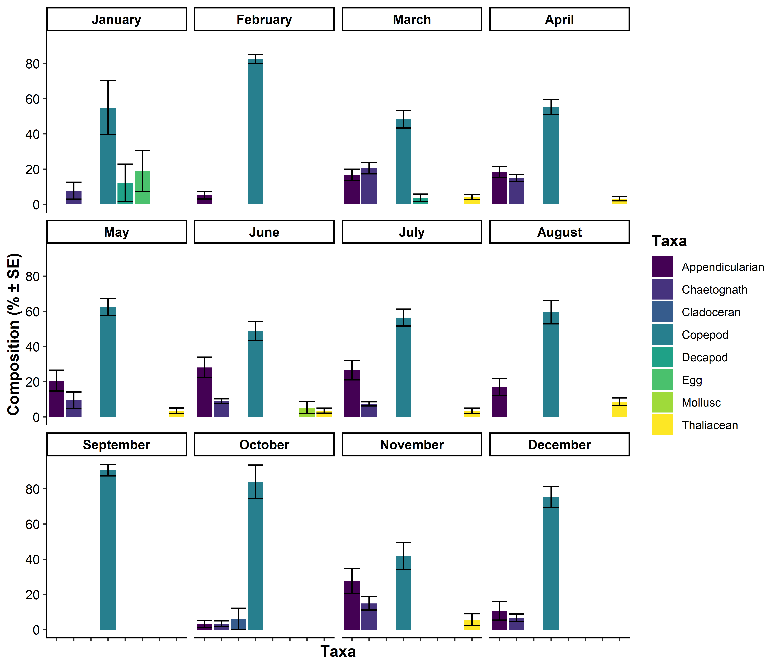**Figure 3** Monthly zooplankton composition based upon continuous plankton recorder data (n = 455) in eastern Australia (28 – 32°S, 152- 155°E, 2009 - 2020). Error bars show ±1 standard error. Note Taxa are also arranged alphabetically along the x-axis and taxa <3 % in all months were omitted from the plots.

*Cape Byron (28.6°S)*

The northernmost transect at Cape Byron (28.6°S) was dominated by the EAC which had a strong alongshore flow (1.50 m s-1; Figure 4). The EAC was centred 27.6km offshore, above the 200 m isobath. Most of the continental shelf was flooded by warm EAC water (Figure 5). There was evidence of uplift with the 21 °C isotherm rising to the surface from 70 m depth over 5 km and the 20 °C isotherm rising to the surface from 100 m depth over 15 km. The EAC showed slight onshore movement which increased offshore and with depth, peaking between 100 and 200 m depth (up to 0.26 m s-1, Figure S4). Due to the proximity of the strong EAC from the continental slope and the lack of upwelling-favourable wind stress (Figure S3), the isotherm uplift is likely to be current-driven, as shown in Schaeffer *et al*. (2014).

A decline in particulate (zooplankton) biomass and abundance was observed from both inshore to offshore and from the surface to depth with the highest biomass (~750 mg m-3; Figures 5, S5, S6, S7) observed at the surface ~20 km from the coastline, just inshore of the 21 °C isotherm (Figure 5a). The warmer offshore EAC waters were characterised by lower zooplankton biomass with a GMS of ≈450 µm ESD (Figure 6) with steep size spectrum slopes between -1 and -1.3 (Figure 5). The cooler water immediately inshore of the 21 °C isotherm had high particulate (zooplankton) biomass and a shallower size spectrum slope (-0.9; Figure 5) with larger particles (GMS 500 µm ESD; Figure 6). Further inshore again (15 -17 km from the coastline), in water < 20 °C, biomass remained high (Figure 5), but the particles were smaller (GMS ≈430 µm ESD; Figure 6), resulting in a steeper size spectrum slope(≈-1.25; Figure 7). No depth resolved cross shelf chlorophyll *a* or nutrient data was available for the Cape Byron transect but there was a gradient in both salinity and temperature across the shelf. Warmer saltier water was found in offshore water, with the salinity both showing similar uplift onto the shelf as described above for the temperature isotherms (Figure S9).

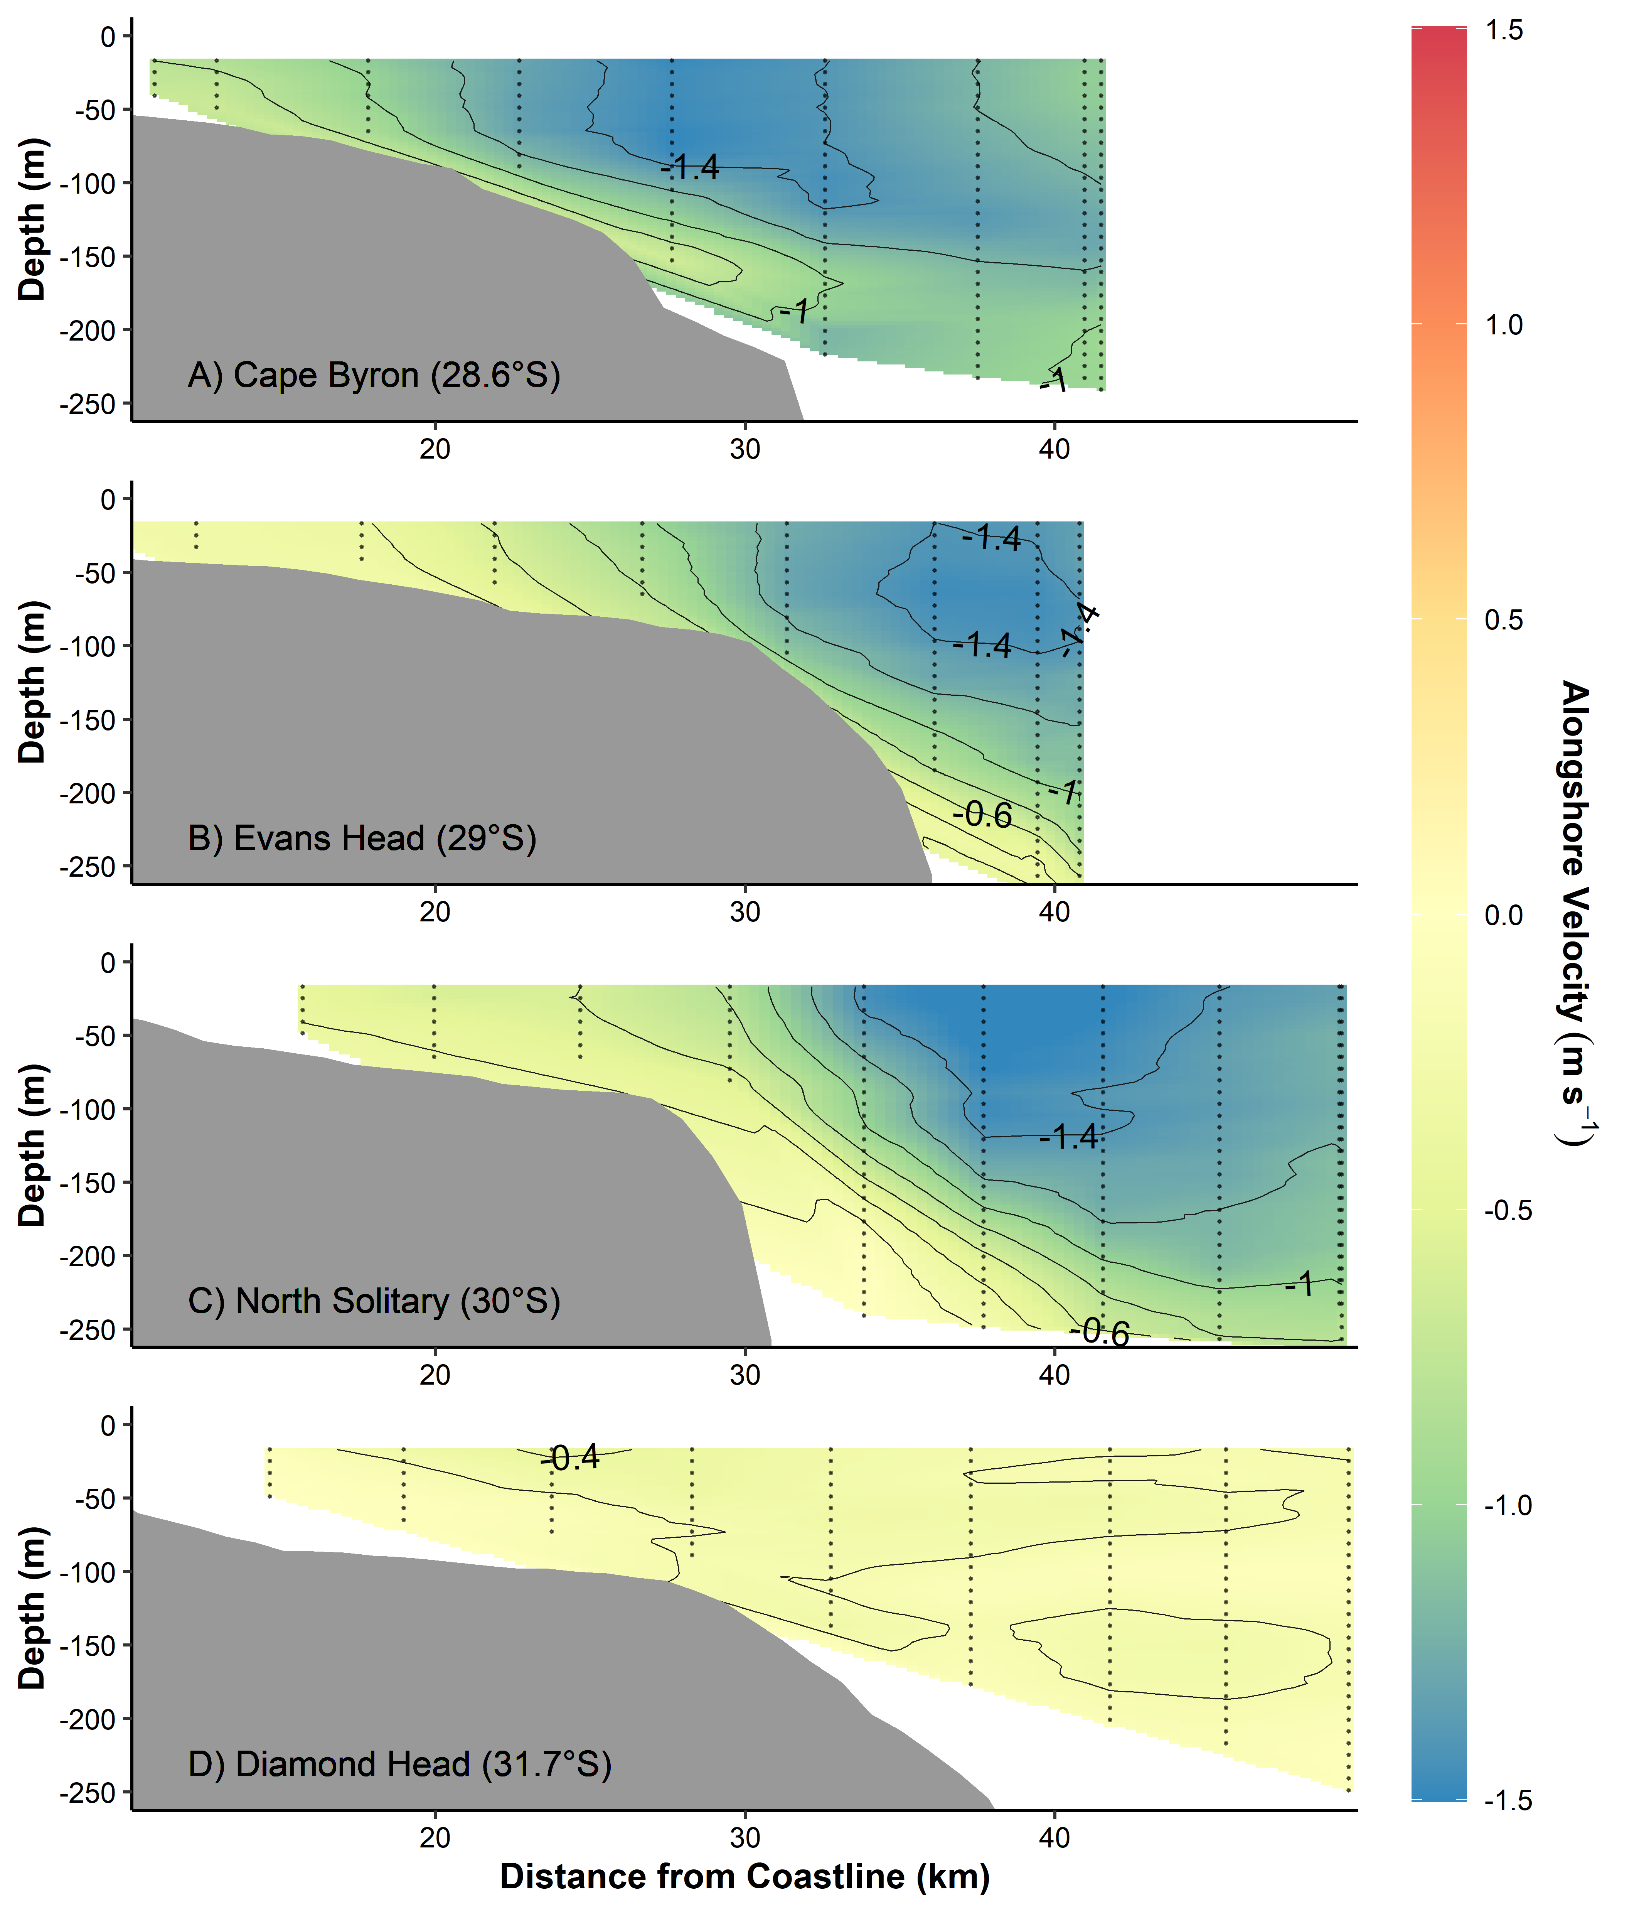

**Figure 4** Alongshore (towards ~195°, minor variation in coastline angle between sites) velocity across the four cross shelf transects (Figure 1), from the vessel’s Acoustic Doppler Current Profiler. Grey lines join areas of equal velocity.

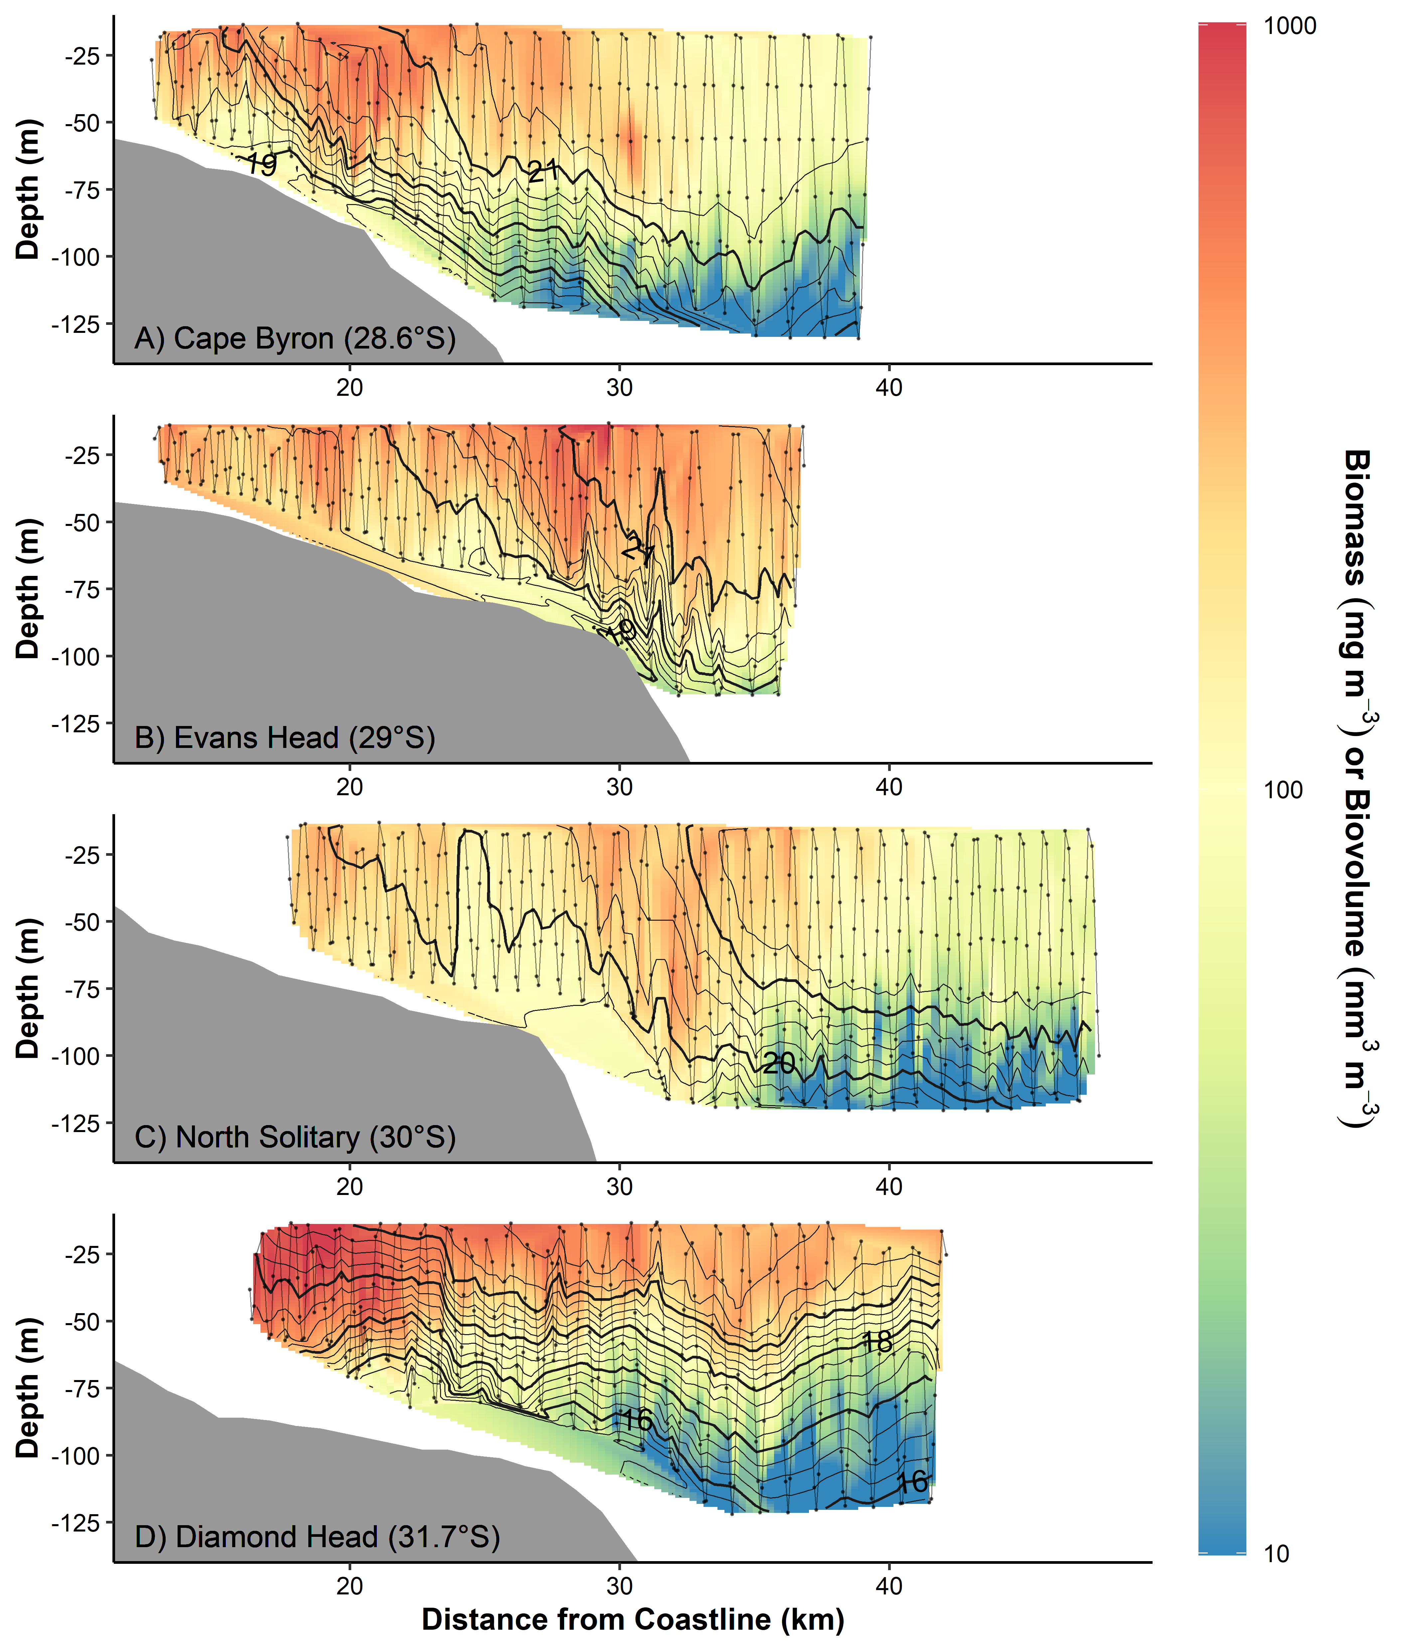

**Figure 5** Particulate (zooplankton) biomass (mg m-3) and biovolume (mm m-3) distributions from the four cross shelf transects (Figure 1). Transects were conducted from inshore to offshore with an undulating towed body with the path shown by the grey line with midpoints of each sample shown as dots. Temperature (°C) isotherms are shown in black. Note biomass the log10 transformed colour scale.

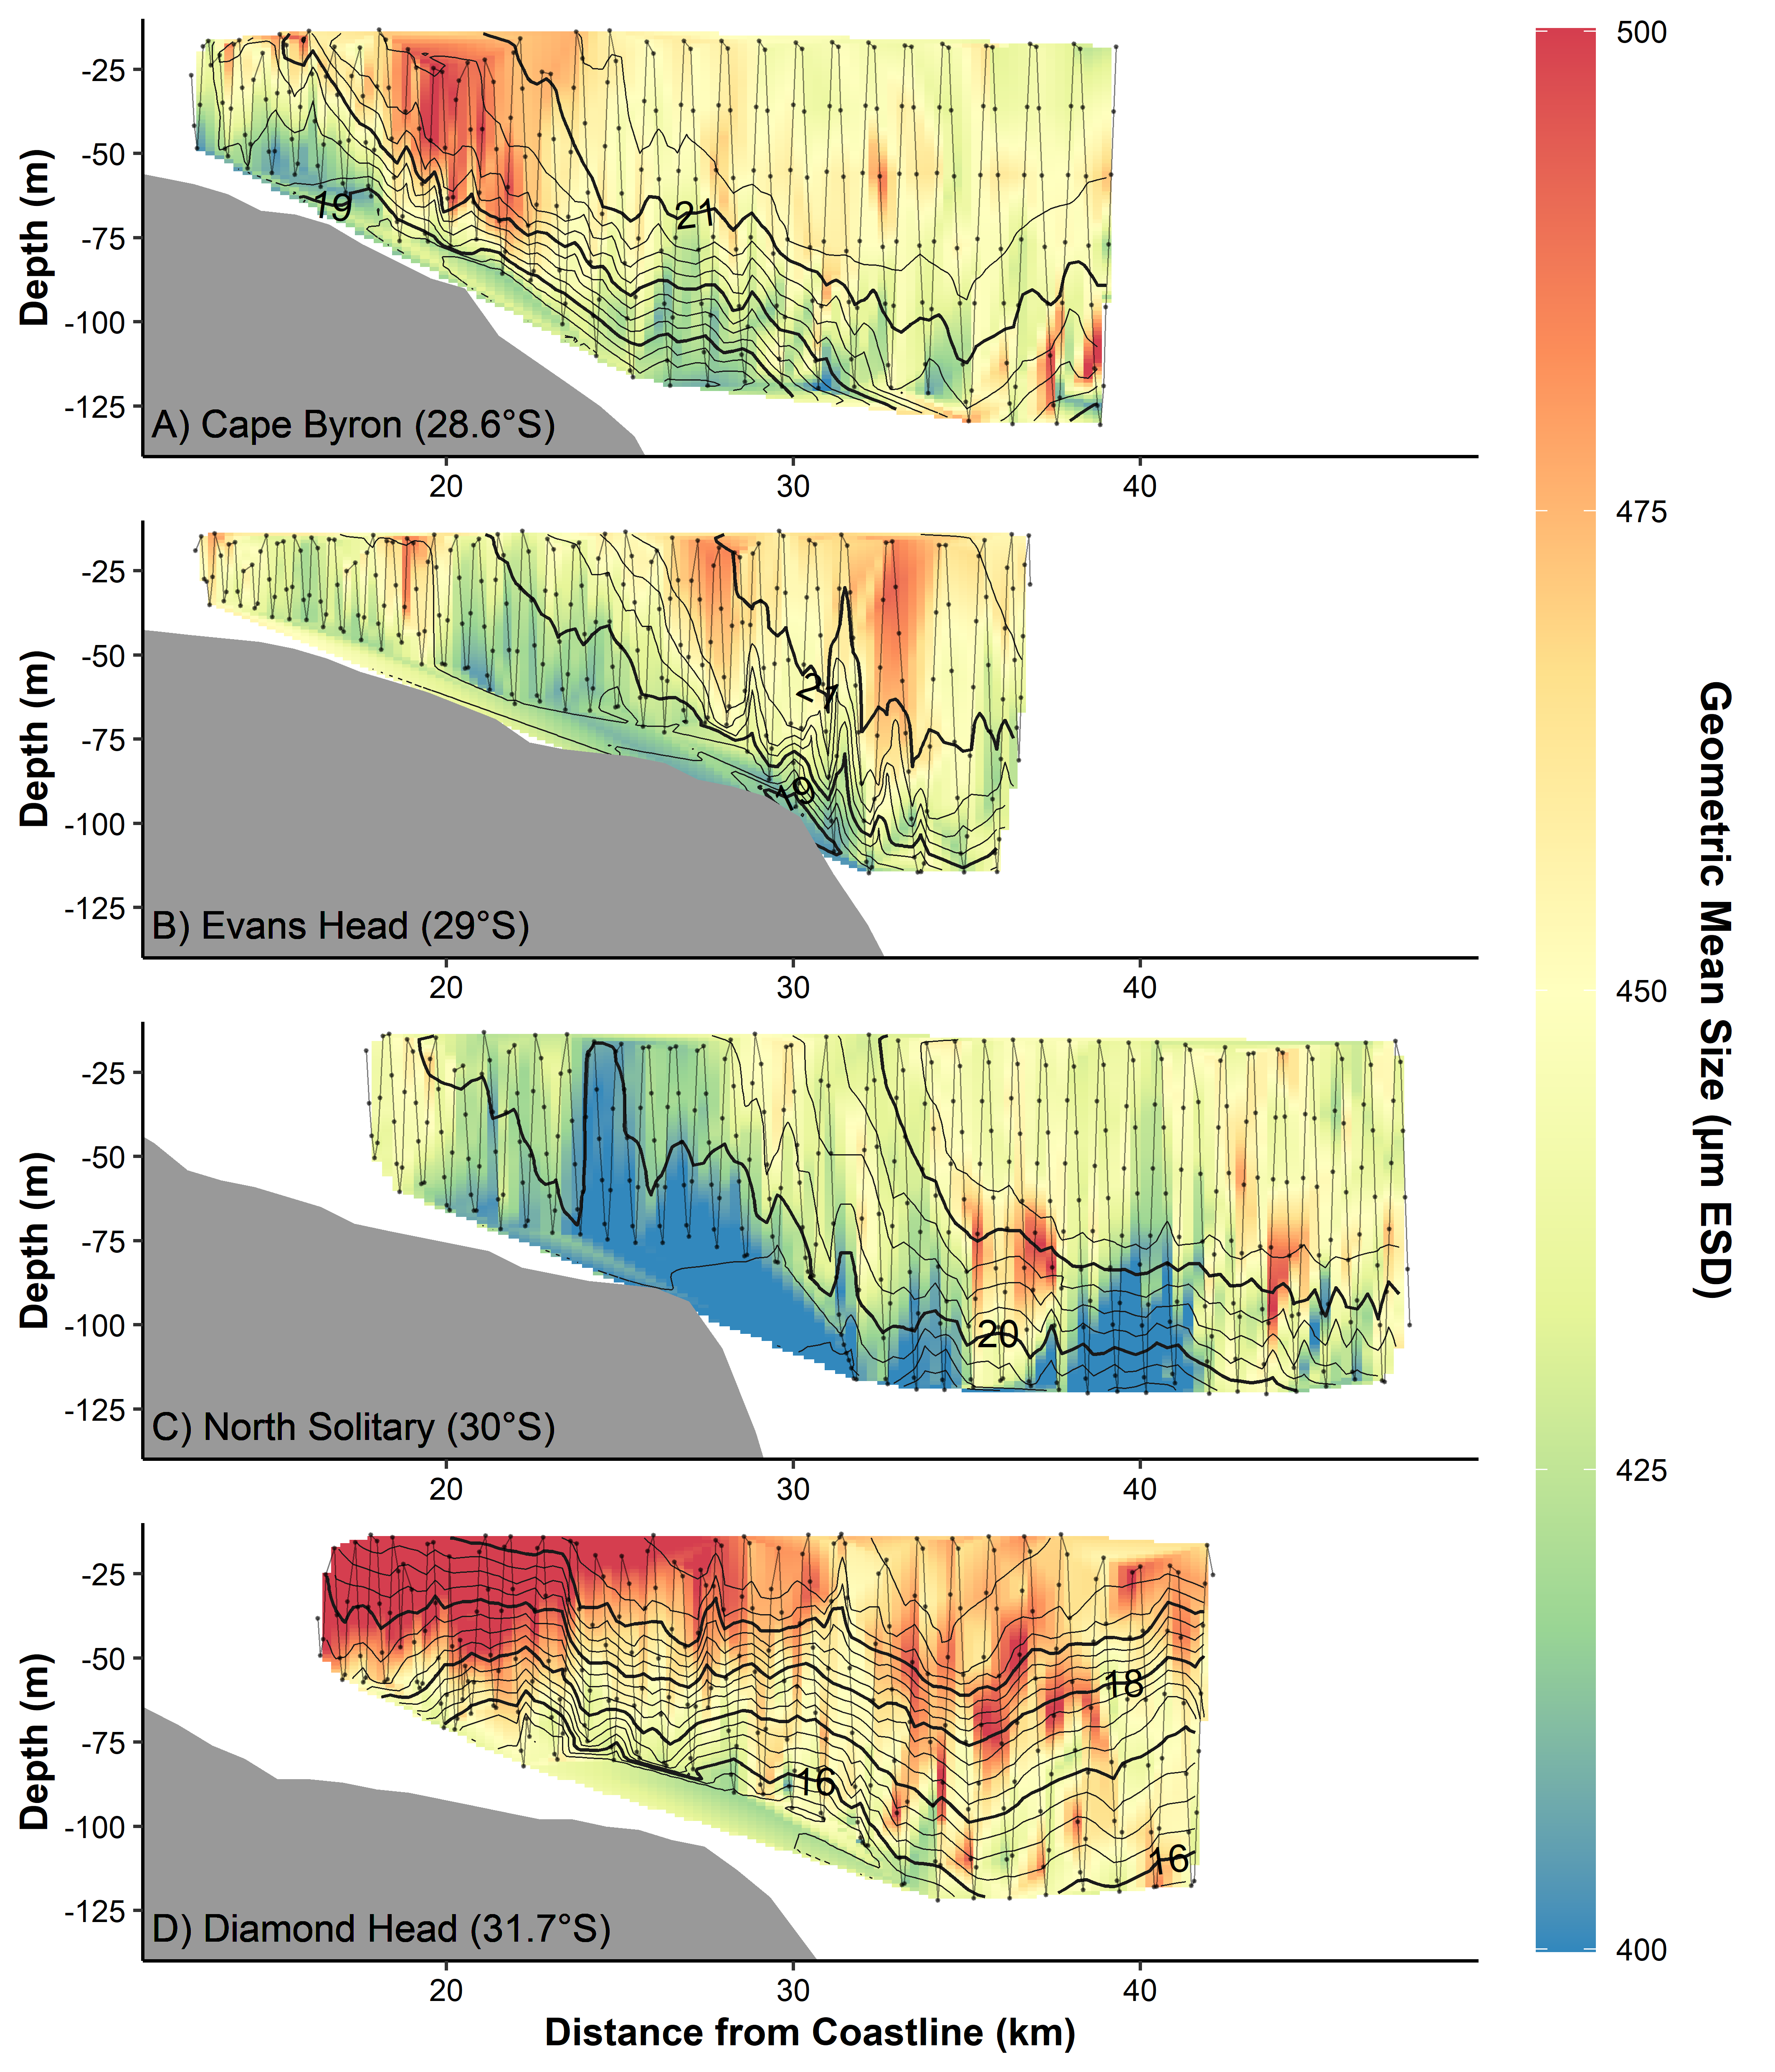

**Figure 6** Geometric Mean Size (µm equivalent spherical diameter) of particulates (zooplankton) from the four cross shelf transects (Figure 1). Transects were conducted from inshore to offshore with an undulating towed body with the path shown by the grey line with midpoints of each sample shown as dots. Temperature (° C) isotherms are shown in black.

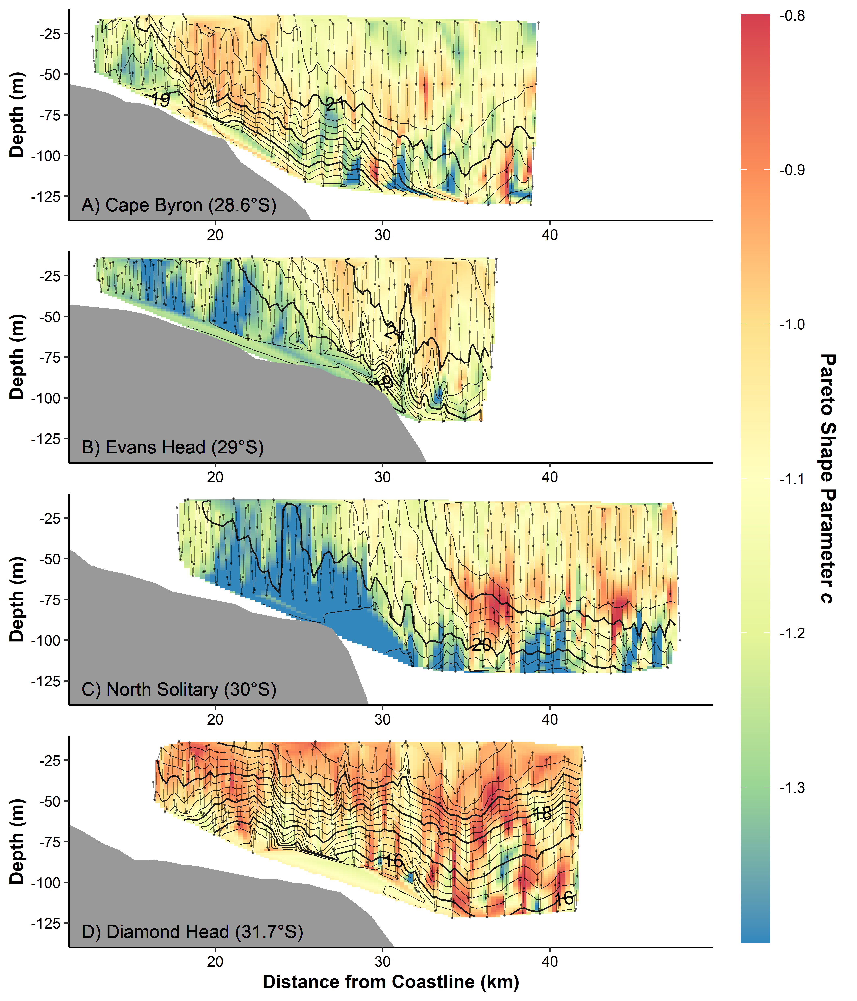

**Figure 7** Interpolations of the shape parameter *c* from the Pareto distribution of particulate (zooplankton) size from the four cross shelf transects (Figure 1). This is a robust estimate of the normalised biomass size spectrum slope (shown in Figure S8). Transects were conducted from inshore to offshore with an undulating towed body with the path shown by the grey line with midpoints of each sample shown as dots. Temperature (° C) isotherms are shown in black.

*Evans Head (29°S)*

The transect at Evans Head (29°S) extended only 5km past the continental shelf edge but was still largely influenced by the EAC. The EAC was centred 36.1km from the offshore above the 220m contour. The EAC had a strong along-shore flow (1.47 m s-1; Figure 4). The EAC showed offshore movement (0.27 m s-1) which increased with distance offshore (Figure S4). There was strong  uplift of the isotherms inshore of the EAC with the 21 °C isotherm rising to the surface from 70 m depth over 6 km and the 20 °C isotherm rising to the surface from 100 m depth over 15 km. Due to the proximity of the strong EAC from the continental slope and the lack of upwelling-favourable wind stress (Figure S3), the isotherm uplift is likely to be current-driven, as shown in Schaeffer et al. (2014).

The particulate (zooplankton) size structure varied along the transect. The EAC was warmer and saltier compared to the inner shelf water (Figure S9). There was also a slight gradient in nitrate and chlorophyll *a* with higher levels of both in the inshore waters (3 mmol m-3 and 1.35 mg m-3 respectively; Figures S10 & S11). In the warmer offshore water the zooplankton biomass and geometric mean size was similar that offshore at Cape Byron while in the cool inshore waters, there was again high particulate (zooplankton) biomass (Figure 5), but the community had shifted towards smaller particles which resulted in a steeper *c* (< -1.3; Figures 5 & 6). There was also low abundance in the deeper samples (Figure S7).

*North Solitary (30°S)*

The transect at North Solitary (30°S) showed the strongest evidence of uplift of any of the transects with the 21 °C isotherm rising to the surface from 70 m depth over 3 km and the 20 °C isotherm rising to the surface from 100 m depth over 10 km (Figure 5). The EAC was centred of the EAC was 37.7 km offshore (alongshore flow 1.59 m s-1), located above the 310 m bathymetry contour (Figure 4). This uplift could potentially have been driven by the upwelling favourable winds in the hours leading up to sampling (Fig S3). The offshore waters of the EAC showed slight onshore movement, at depths of 100-150m (0.15 m s-1; Figure S4).

Biomass and abundance generally decreased with distance offshore and with depth (Figures 5, S5 & S6, S7). The warmer water, located offshore, contained low biomass with a shallow pareto distribution shape parameter *c* (-0.9) and GMS of ~450 µm (Figures 5, 6 & 7). Zooplankton in cooler water < 20 °C had a much smaller GMS (~400µm ESD) resulting in a steeper *c* (< -1.3). This was particularly evident where the 20°C isotherm reach the surface ~24 km from the coastline, bringing with it a potentially highly productive zooplankton community (Figures 6 & 7). This peak also aligned with a minor peak in chlorophyll *a* (1.45 mg m-3; Figure S11). North Solitary showed evidence of uplift with the small GMS community from deep uplifted to the surface. The uplift could have resulted from the close-by EAC and the short upwelling-favourable wind a few hours before sampling. The deep cold water (< 16°C) had higher levels of nitrate and silicate (Figures S10 & S12), but this does not appear to have been lifted to the surface waters with the surface waters low in nutrients across the transect.

*Diamond Head (31.75°S)*

The most southern transect located at Diamond Head (31.75°S) was not influenced by the EAC which had separated from the coast to the north and was characterised by a more homogeneous water mass. Here, the alongshore velocities were low (< 0.43 m s-1, Figure 4) with low onshore movement of water (0.11 m s-1) in the surface waters and offshore movement (0.27 m s-1) in the deeper waters (Figure S4). The lack of horizontal variation was reflected in the nitrate, silicate, temperature and salinity with almost all variation being observed with depth (Figures S9, S10, S12). Chlorophyll *a* and oxygen showed small peaks (1.2 mg m-3 and 240 mmol m-3 respectively; Figures S11 & S13) at the surface near the beginning of the transect. There was minor uplift of the temperature isotherms with all isotherms rising approximately 20 – 40 m as they came onto the continental shelf. This uplift is likely caused by the separation of the EAC from the coast to the north, generating uplift through the creation of eddies near Diamond Head rather than current driven uplift observed at the northern EAC influenced sites (Roughan and Middleton, 2002; Schaeffer and Roughan, 2015).

This transect has the highest observed biomass of particles (>1000 mg m-3), particularly inshore (Figure 5). The size structure was not clearly related to water masses reflecting the more homogenous water mass here. Inshore, the particulate (zooplankton) community was charactered by larger individuals (GMS ~500 µm ESD; Figure 6) and had higher overall biomass which declined steadily with distance offshore and with depth (Figures 5, S5 & S6). The pareto distribution shape parameter *c* of the community was shallow over the whole transect (≈-0.9; Figure 7).

*Synthesis of Transect Patterns*

The influence of the EAC varied between the three transects. The three northern transects were influenced strongly by the EAC, particularly the offshore sections while the Diamond Head transect was not influenced by the EAC. At the two northern sites the EAC was located close to the continental shelf and likely drove current driven upwelling. In contrast at the North Solitary site, the EAC was located further offshore, and the weaker observed uplift was potentially caused by wind driven upwelling (Fig S3).

The Cape Byron, North Solitary and Diamond Head transects had higher particulate (zooplankton) biomasses observed in continental shelf waters with declines offshore and with depth in the top 100m of the water column (Figures S5 & S6). The transect at Evans Head did not show a noticeable decline in biomass with distance from the coast but this transect did not extend past the edge of the continental shelf where the declines were seen in the other 3 transects.

Three patterns in GMS were evident in our 4 transects. Cape Byron and to a lesser extent, Evans Head showed evidence of larger GMS around the front between the warm EAC and cooler inner shelf water (around the 21 °C isotherm; Figure 6). North Solitary showed evidence of uplift with the small GMS community from deep uplifted to the surface. The uplift could have resulted from the close-by EAC and the short upwelling-favourable wind a few hours before sampling. Diamond Head was very different with a more homogenous distribution of GMS although there was a trend of larger particulates (zooplankton) inshore. The size structure of all sites was related to the GMS with steeper size spectrum slopes in areas with smaller zooplankton (Figures 6 & 7). The Pareto *c* shape parameter was highly correlated with the NBSS Slope but provided better fewer gaps (due to low numbers of particles) over the transects (*r* = 0.934, *t*535 = 60.362, *p* < 0.001, Figure S8).

*Global Synthesis*

19 studies quantified the cross-shelf changes in zooplankton (including this study), revealing a broad consensus (Figure 8; Table S1), even though many studies were not influenced by a western boundary current. Seven studies (including ours) reported abundance values for inshore and offshore and all found that abundance was higher in inshore regions compared to offshore regions. Six of these studies showed inshore areas abundance of 2.3 – 4.2 times higher than offshore values with one study from the eastern Bay of Biscay region finding a 22-fold difference (Sourisseau and Carlotti, 2006). For biomass, six of seven studies showed 1.5 – 4.1-fold greater biomass inshore compared with offshore (Figure 8; Table S1). The sixth study from the Western Mediterranean showed 20-fold higher biomass offshore compared to inshore values (Sabatès *et al.*, 1989).

In terms of size structure, 11 studies reported both inshore and offshore values with nine finding steeper zooplankton size spectrum slopes in inshore areas compared with offshore areas (Figure 8, Table S1). The southern Bay of Biscay and North Iberian Shelf studies were unusual in having a shallower inshore zooplankton size spectrum slope compared to the offshore areas (Nogueira *et al.*, 2004; Vandromme *et al.*, 2014).

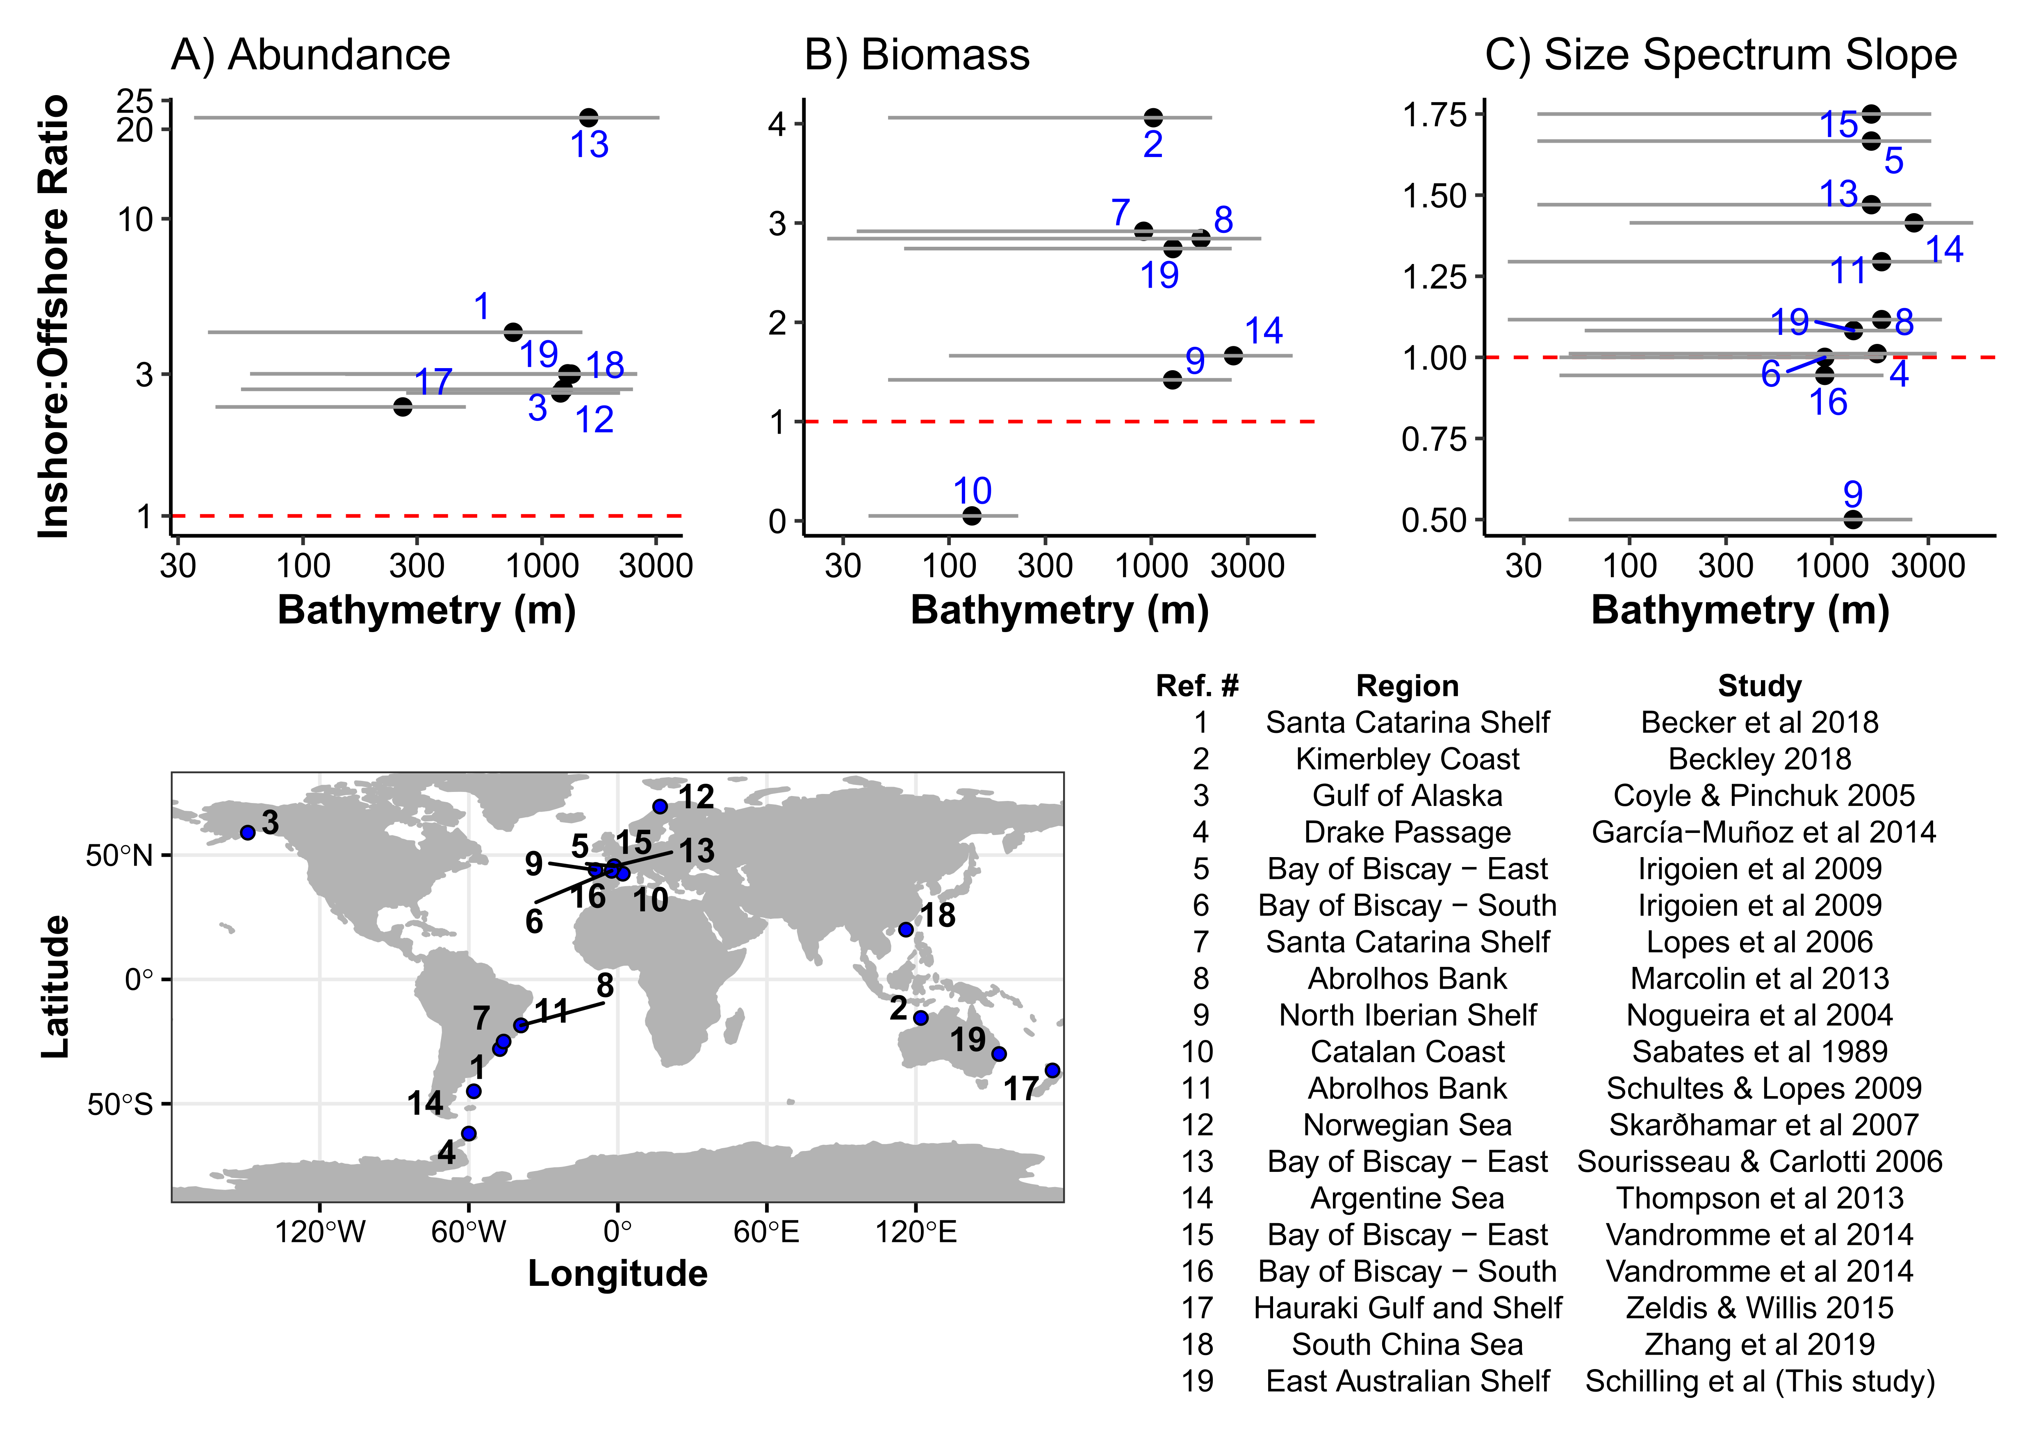

**Figure 8** Summary of 18 previous studies investigating cross shelf patterns of zooplankton (#19 is the current study). The y-axis shows the ratio of the inshore to offshore reported values for zooplankton A) Abundance, B) Biomass, and C) the Size Spectrum Slopes. A ratio greater than 1 (red dashed line) means that the inshore region had a larger abundance/biomass or steeper size spectrum. Each numbered dot represents a study except for the studies in the Bay of Biscay which identified east and south as distinct region so they remain independent (Table S1; Irigoien *et al.*, 2009; Vandromme *et al.*, 2014). The x-axis represents the bathymetry range from each study with the dot on the mean value for that study. Note the differing y-axes and log10 x-axis on a), and that not all studies are in western boundary current influenced locations.

Discussion

The size-spectrum of zooplankton provides important information about the transfer of energy from phytoplankton to fish, from which we can understand how fisheries are supported on continental shelves. We found consistent declines from inshore to offshore in particulate (zooplankton) biomass and variation in size-structure both horizontally and vertically across the narrow continental shelf off eastern Australia (Figure 9). These horizontal trends in the particulate (zooplankton) size-structure are consistent with the patterns in size-structure across other continental shelves and likely are an outcome of nutrient enrichment which tends to occur on continental shelves. This enrich can come from a variety of sources including cross-shelf flows and sporadic upwelling processes driven by ocean currents and coastal winds (Roughan and Middleton, 2002; Rossi *et al.*, 2014; Malan *et al.*, 2020), estuarine process (Morris *et al.*, 1995) or run-off from land (Correll *et al.*, 1992).

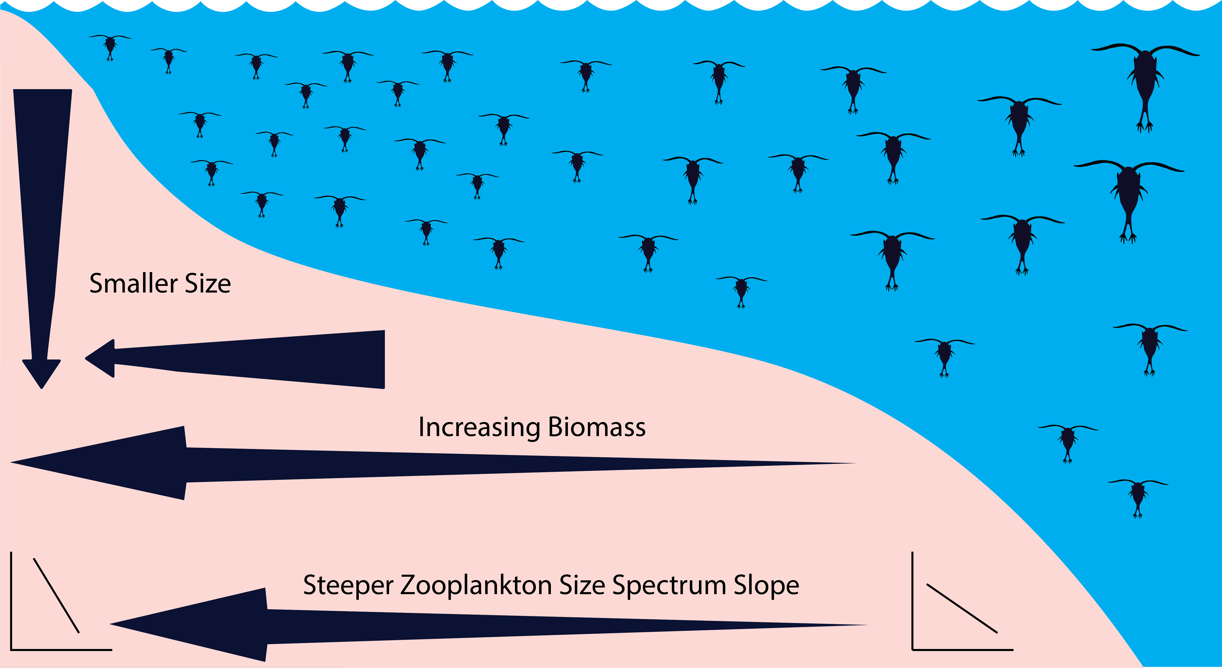**Figure 9** Conceptual diagram of the zooplankton community and how it changes over the east Australian continental shelf and with depth. Note all zooplankton are represented by copepods in this diagram.

The cross-shelf observations of chlorophyll *a* and nutrients showed little patterns across our transects the majority of variation in water properties being observable through temperature and salinity. The warm salty EAC dominated the upper 100m of the offshore portions of the three northern transects with cooler inner shelf water. At Cape Byron and Evans Head, the EAC was in high proximity to the continental slope and the lack of upwelling-favourable wind stress (Figure S3) suggests that the observed isotherm uplift is likely to be current-driven, as shown in Schaeffer et al. (2014). This was contrasted by North Solitary where the EAC was further offshore and it was likely the uplift was at least partially caused by the upwelling favourable winds in the hours prior to sampling (Figure S3). As a contrast, Diamond Head which was located south of the EAC separation and therefore free from its influence was largely homogenous with little horizontal structure and limited uplift of isotherms. Particulate (zooplankton) biomass and mean size was generally reflective of the horizonal and vertical structure of the water. The cooler shelf water revealed a particulates (zooplankton) with higher biomass, smaller geometric mean size and steeper size spectrum slope (Figures 5, 6, 7), distinct from the warmer offshore EAC. These observations are consistent with sustained higher chlorophyll *a* on the continental shelf (Everett *et al.*, 2014) and are likely driven by uplift of the cooler water due to the EAC interacting with the sloping topography (Schaeffer *et al.*, 2014; Schaeffer and Roughan, 2015). As zooplankton are the basis of many coastal food webs, this consistent supply of nutrients is an important factor in the distribution and abundance of planktivorous fish and the higher trophic level fisheries found on continental shelves (Pauly *et al.*, 2002; Truong *et al.*, 2017; Holland *et al.*, 2020). Therefore, a steeper zooplankton size spectrum slope could arise not only from increased production of smaller zooplankton (Guiet *et al.*, 2016), but also by predation on larger zooplankton prey by planktivorous fish (Moore and Suthers, 2006). In the region of our study, planktivorous fish such as mackerel and scad consume zooplankton in the 0.5-1 mm particle diameters (Schilling, unpublished data) and are often found aggregating on the inside of the shelf edge (Holland *et al.*, 2021). Such predators could steepen the slope of the zooplankton biomass size spectrum as they target larger prey.

*Effects of the EAC on zooplankton*

The separation of the EAC from the Australian coast, where it often bifurcates towards the east, forms a front between the northern oligotrophic waters, and the southern eutrophic Tasman Sea waters (Oke *et al.*, 2019). Offshore, this can separate distinct zooplankton communities (Baird *et al.*, 2008) and with impacts on abundance and diet of fish (Hobday and Hartmann, 2006; Revill *et al.*, 2009). On the continental shelf, the influence of the EAC separation on the distribution of zooplankton and fish is less well known. Our results suggest that along the three northern transects strongly influenced by the EAC, the continental shelf waters are to a small extent influenced by uplift of deep nutrient-rich water mostly driven by the close proximity of the EAC to the continental shelf (Roughan and Middleton, 2002), which drives the higher biomass of phytoplankton (Everett *et al.*, 2014) and therefore zooplankton. Closer inshore, the effects of predation pressure from fish in the littoral zone, particularly on temperate reefs, may remove larger plankton (Truong *et al.*, 2017; Holland *et al.*, 2020, 2021). Therefore a steeper zooplankton size spectrum slope could arise not only from increased production of smaller zooplankton (Guiet *et al.*, 2016), but also by predation on larger zooplankton prey by planktivorous fish (Moore and Suthers, 2006).

In contrast to the northern transects, the southern transect (Diamond Head; 31.75°S) was south of the EAC separation zone and dominated by Tasman Sea water resulting in larger particles and a shallower size spectrum slope. The same pattern of decreasing biomass offshore, and with depth in the water column occurred. In general, the Tasman Sea has an elevated nutrient concentration and higher particulate (zooplankton) biomass compared to the oligotrophic EAC waters (Baird *et al.*, 2008), this was observed in our surveys to a limited extent with the EAC showing very small nutrient concentrations compared to the deeper and inner shelf waters (Figures S10 & S12). At our southern site there are two possibilities for this cross shelf gradient. Firstly, as there was minimal EAC influence at the southern site it is possible that the zooplankton are being retained on the continental shelf in this location due to weak flow in the lee of the EAC separation (Everett *et al.*, 2014; Schaeffer and Roughan, 2015). Secondly, this region has been shown to have high chlorophyll *a* production due to both wind driven and current driven upwelling with wind driven upwelling reliably generating increases in chlorophyll *a* (Everett *et al.*, 2014). This production may then flow through into the zooplankton community.

While this study provides the first high-resolution depth-resolved cross shelf transects, it is limited to the top 100m of the water column and there may be some influence of diel vertical migration of zooplankton on the vertical distribution. Despite this possibility we think the results are robust as two of the samples were conducted at night and two during the day with all four transect showing similar vertical gradients in particulate (zooplankton) properties. Furthermore, we did not sample in areas where the bathymetry was less than 50 m, where the inshore water masses are more influenced by terrestrial inputs, waves, wind-driven vertical mixing.

*Comparison to other studies*

Our study showed a consistent decline in biomass with increasing distance from shore and with increasing depth (to 100m depth) with the largest biomasses observed in the surface inner shelf waters, likely due to coastal nutrient enrichment (from a variety of mechanisms). This was similar to almost all other comparable studies with the exception being the western Mediterranean which is not located in a boundary current system but included in our continental shelf comparison for completeness (Sabatès *et al.*, 1989). Despite different regional dynamics, cross-shelf and vertical gradients in water-masses, here driven by the EAC and uplift, seem to be the dominant factor for the patterns observed at various locations worldwide. In the northeast Atlantic, the declining pattern of biomass across the shelf was attributed to coastal nutrient inputs and long residence times of water masses over the shelf break (Sourisseau and Carlotti, 2006; Irigoien *et al.*, 2009; Vandromme *et al.*, 2014). However, in the Brazilian Bight (southwest Atlantic), the increase in inshore zooplankton biomass was attributed to bottom intrusions of cooler nutrient rich South Atlantic Central Water (Pereira Brandini *et al.*, 2014). Further south of the Brazilian Bight, similar results were observed on the Abrolhos Bank where higher zooplankton biomass was observed on the continental shelf due to the Brazil Current interacting with the sea-floor, generating uplift and eddies which increased mixing over the continental shelf (Marcolin *et al.*, 2013).

In the southwest Pacific, there are relatively small terrestrial influences compared to other sources of nutrients such as upwelling are important (Apte *et al.*, 1998; Dai and Trenberth, 2002; Pritchard *et al.*, 2003; Suthers *et al.*, 2011). Similar to the Brazil Current and the Abrolhos bank, in the southwest Pacific the EAC interacts with the topography which in turn generates uplift of cooler water onto the continental shelf (Roughan and Middleton, 2002).

Steeper zooplankton size spectrum slopes in inshore regions is another feature of zooplankton communities which are consistently observed. In some regions the areas of steepest slopes have been linked to estuarine-derived nutrients (Moore and Suthers, 2006; Irigoien *et al.*, 2009), which are exploited by nearshore planktonic communities while steep slopes occurring further offshore are more temporally consistent and potentially due to local circulation patterns and retention (Vandromme *et al.*, 2014). Within the cross-shelf patterns of zooplankton, biomass and mean size also tend to decline with depth in the water column.

There are exceptions to the general trends that we identified in biomass, abundance and size spectrum slope. For example, Nogueira et al. (2004) showed a shallow inshore slope compared to offshore, which was attributed to nearby continental inputs increasing the proportion of large zooplankton possibly due to a eutrophic environment (Atkinson *et al.*, 2020). Some studies also show these onshore-offshore gradients are highly variable as observed in the East China Sea where onshore-offshore gradients in different years showed no consistency, but insufficient data was provided for these samples to be included in our analysis (García-Comas *et al.*, 2014). This temporal instability in some regions may suggest that repeated surveys under different oceanographic conditions may be necessary to fully understand the drivers of zooplankton on continental shelfs. The current study had no temporal replication and while it was shown that the conditions which were sampled are regularly occurring features, additional studies would be useful to confirm the occurrence of the patterns in particulate (zooplankton) biomass and size structure.

While none of the previous studies have examined the vertical structure of continental shelf zooplankton communities in the same detail as horizontal structure, several studies have made similar conclusions to that observed in the current study. In the southeast Atlantic, a higher biomass of zooplankton was found above the pycnocline attributed to the increased chlorophyll *a* in these waters (Marcolin *et al.*, 2013). In the northwest Atlantic, a similar strong association was found with a thermocline, with distinct zooplankton communities across the continental shelf separated by the 15° C thermocline (Turner and Dagg, 1983). Similar patterns in zooplankton size structure are observed around thermoclines in subtropical Australia (Suthers *et al.*, 2006).

*Implications for the future*

While the distributions and patterns observed in the current study align with global observations, they are only a snapshot and at other times of the year the patterns may vary. Our analysis of seasonal influence by the EAC showed that while there are seasonal variations in alongshore current velocity due to the EAC (Figure 4), the velocities observed in our study reflect a large portion of the year in terms of the velocities at our transect locations. Despite this, the EAC is strengthening (Suthers *et al.*, 2011; Wu *et al.*, 2012), and the increasing water temperatures in the southeast Australian region (Malan *et al.*, 2021), are already impacting the zooplankton communities as the region becomes increasingly tropicalised (Kelly *et al.*, 2016). At long term observing stations in the southeast Australian region, warming waters have resulted in a reduction in the spring phytoplankton bloom and > 60% decline phytoplankton growth during spring (Thompson *et al.*, 2009). These changes may have significant bottom-up effects on the overall distribution of zooplankton biomass, size structure and community composition on continental shelves as zooplankton are impacted across the globe in similar ways (Richardson, 2008). With the impacts of warming oceans already being observed at coastal observing stations and phytoplankton communities increasingly dominated by warm-water tolerant chain forming diatoms (Ajani *et al.*, 2020), impacts from projected reductions in both phytoplankton and zooplankton biomass are likely to be amplified up the food chain with potentially large impacts on fisheries as food web become increasingly reliant on pelagic energy sources rather than benthic (Petrik *et al.*, 2020).

*Conclusions*

Based upon the general cross shelf patterns and the depth resolved data from the present study we suggest a general process for the distribution of zooplankton on continental shelves influenced by boundary currents (Figure 9). This heuristic model includes expectations for future studies to examine, such as the decline in zooplankton biomass with distance offshore and with depth in the water column. This is potentially driven by cross-shelf differences in nutrient input which in our area was driven by the East Australia Current which drives productivity on the shelf through uplift of nutrient rich waters. Future studies could answer these questions with more sustained monitoring of cross-shelf patterns in zooplankton size structure throughout the year.

**Acknowledgements**

The authors wish to thank the Marine National Facility, the captain and crew of *RV Southern Surveyor* 08/2004, chief scientist Jason Middleton and especially voyage manager Lindsey Pender. HTS was supported by a NSW Government Research Attraction and Acceleration Program grant awarded to SIMS. This research was funded by ARC Discovery Projects DP0209193 held by IMS. and MEB, DP0208663 held by Jason Middleton., and DP0557618 held by MEB. JDE was supported by DP150102656 and DP190102293. Satellite data was sourced from Australia’s Integrated Marine Observing System (IMOS) – IMOS is enabled by the National Collaborative Research Infrastructure strategy (NCRIS).

**Author Contributions**

MEB & IMS conceived the study and collected the data. HTS, JDE, AS & PY analysed the data. HTS wrote the first draft and all authors contributed to and approved the final manuscript.

**Data Availability**

All data used in this study are freely accessible. The data from the Southern Surveyor voyage 08/2004 is available from the CSIRO Data Trawler (<https://www.marine.csiro.au/data/trawler/>). The long term environmental data is available from the Australian Ocean Data Network (<https://portal.aodn.org.au/>). All code used for the analysis in this paper is available in the GitHub repository <https://github.com/HaydenSchilling/Inner-Shelf-Water>.

**Competing Interests Statement**

The authors declare no competing interests.

**References**

Aguiar, A. L., Cirano, M., Pereira, J., and Marta-Almeida, M. 2014. Upwelling processes along a western boundary current in the Abrolhos–Campos region of Brazil. Continental Shelf Research, 85: 42–59.

Ajani, P. A., Davies, C. H., Eriksen, R. S., and Richardson, A. J. 2020. Global Warming Impacts Micro-Phytoplankton at a Long-Term Pacific Ocean Coastal Station. Frontiers in Marine Science, 7. Frontiers. https://www.frontiersin.org/articles/10.3389/fmars.2020.576011/full?utm_source=F-AAE&utm_medium=EMLF&utm_campaign=MRK_1467818_45_Marine_20201027_arts_A (Accessed 4 May 2021).

Akima, H., and Gebhardt, A. 2020. akima: Interpolation of Irregularly and Regularly Spaced Data. R package version 0.6-2.1. https://CRAN.R-project.org/package=akima.

Alldredge, A. L., and Silver, M. W. 1988. Characteristics, dynamics and significance of marine snow. Progress in Oceanography, 20: 41–82.

Andersen, K. H., Berge, T., Gonçalves, R. J., Hartvig, M., Heuschele, J., Hylander, S., Jacobsen, N. S., *et al.* 2016. Characteristic Sizes of Life in the Oceans, from Bacteria to Whales. Annual Review of Marine Science, 8: 217–241.

Apte, S. C., Batley, G. E., Szymczak, R., Rendell, P. S., Lee, R., and Waite, T. D. 1998. Baseline trace metal concentrations in New South Wales coastal waters. Marine and Freshwater Research, 49: 203–214.

Archer, M. R., Roughan, M., Keating, S. R., and Schaeffer, A. 2017. On the Variability of the East Australian Current: Jet Structure, Meandering, and Influence on Shelf Circulation. Journal of Geophysical Research: Oceans, 122: 8464–8481.

Armbrecht, L. H., Roughan, M., Rossi, V., Schaeffer, A., Davies, P. L., Waite, A. M., and Armand, L. K. 2014. Phytoplankton composition under contrasting oceanographic conditions: Upwelling and downwelling (Eastern Australia). Continental Shelf Research, 75: 54–67.

Armbrecht, L. H., Thompson, P. A., Wright, S. W., Schaeffer, A., Roughan, M., Henderiks, J., and Armand, L. K. 2015. Comparison of the cross-shelf phytoplankton distribution of two oceanographically distinct regions off Australia. Journal of Marine Systems, 148: 26–38.

Atkinson, A., Lilley, M. K. S., Hirst, A. G., McEvoy, A. J., Tarran, G. A., Widdicombe, C., Fileman, E. S., *et al.* 2020. Increasing nutrient stress reduces the efficiency of energy transfer through planktonic size spectra. Limnology and Oceanography, n/a. https://aslopubs.onlinelibrary.wiley.com/doi/abs/10.1002/lno.11613 (Accessed 26 October 2020).

Baird, M. E., Timko, P. G., Middleton, J. H., Mullaney, T. J., Cox, D. R., and Suthers, I. M. 2008. Biological properties across the Tasman Front off southeast Australia. Deep-Sea Research Part I-Oceanographic Research Papers, 55: 1438–1455.

Bakun, A., and Weeks, S. J. 2008. The marine ecosystem off Peru: What are the secrets of its fishery productivity and what might its future hold? Progress in Oceanography, 79: 290–299.

Barnes, C., Maxwell, D., Reuman, D. C., and Jennings, S. 2010. Global patterns in predator–prey size relationships reveal size dependency of trophic transfer efficiency. Ecology, 91: 222–232.

Blanchard, J. L., Heneghan, R. F., Everett, J. D., Trebilco, R., and Richardson, A. J. 2017. From Bacteria to Whales: Using Functional Size Spectra to Model Marine Ecosystems. Trends in Ecology & Evolution, 32: 174–186.

Brink, K. H. 2016. Cross-Shelf Exchange. Annual Review of Marine Science, 8: 59–78.

Carr, M.-E., and Kearns, E. J. 2003. Production regimes in four Eastern Boundary Current systems. Deep Sea Research Part II: Topical Studies in Oceanography, 50: 3199–3221.

Cetina-Heredia, P., Roughan, M., van Sebille, E., and Coleman, M. A. 2014. Long-term trends in the East Australian Current separation latitude and eddy driven transport. Journal of Geophysical Research: Oceans, 119: 4351–4366.

Correll, D. L., Jordan, T. E., and Weller, D. E. 1992. Nutrient flux in a landscape: Effects of coastal land use and terrestrial community mosaic on nutrient transport to coastal waters. Estuaries, 15: 431–442.

Cowley, R. 1999. Hydrochemistry operations manual. CSIRO Marine Laboratories, 236. CSIRO Div. of Marine Research, Hobart, Tasmania. https://doi.org/10.4225/08/585d676eb38c9.

Dai, A., and Trenberth, K. E. 2002. Estimates of Freshwater Discharge from Continents: Latitudinal and Seasonal Variations. Journal of Hydrometeorology, 3: 660–687.

D’Croz, L., and O’Dea, A. 2007. Variability in upwelling along the Pacific shelf of Panama and implications for the distribution of nutrients and chlorophyll. Estuarine, Coastal and Shelf Science, 73: 325–340.

Edwards, A. M., Robinson, J. P. W., Plank, M. J., Baum, J. K., and Blanchard, J. L. 2017. Testing and recommending methods for fitting size spectra to data. Methods in Ecology and Evolution, 8: 57–67.

Espinasse, B., Basedow, S., Schultes, S., Zhou, M., Berline, L., and Carlotti, F. 2018. Conditions for assessing zooplankton abundance with LOPC in coastal waters. Progress in Oceanography, 163: 260–270.

Everett, J. D., Baird, M. E., Oke, P. R., and Suthers, I. M. 2012. An avenue of eddies: Quantifying the biophysical properties of mesoscale eddies in the Tasman Sea. Geophysical Research Letters, 39: 5.

Everett, J. D., Baird, M. E., Roughan, M., Suthers, I. M., and Doblin, M. A. 2014. Relative impact of seasonal and oceanographic drivers on surface chlorophyll a along a Western Boundary Current. Progress in Oceanography, 120: 340–351.

García-Comas, C., Chang, C.-Y., Ye, L., Sastri, A. R., Lee, Y.-C., Gong, G.-C., and Hsieh, C. 2014. Mesozooplankton size structure in response to environmental conditions in the East China Sea: How much does size spectra theory fit empirical data of a dynamic coastal area? Progress in Oceanography, 121: 141–157.

GEBCO Bathymetric Compilation Group. 2019. The GEBCO_2019 Grid - a continuous terrain model of the global oceans and land.

Guiet, J., Poggiale, J.-C., and Maury, O. 2016. Modelling the community size-spectrum: recent developments and new directions. Ecological Modelling, 337: 4–14.

Heneghan, R. F., Hatton, I. A., and Galbraith, E. D. 2019. Climate change impacts on marine ecosystems through the lens of the size spectrum. Emerging Topics in Life Sciences, 3: 233–243.

Herman, A. W. 1992. Design and calibration of a new optical plankton counter capable of sizing small zooplankton. Deep Sea Research Part A. Oceanographic Research Papers, 39: 395–415.

Hobday, A. J., and Hartmann, K. 2006. Near real-time spatial management based on habitat predictions for a longline bycatch species. Fisheries Management and Ecology, 13: 365–380.

Holland, M. M., Smith, J. A., Everett, J. D., Vergés, A., and Suthers, I. M. 2020. Latitudinal patterns in trophic structure of temperate reef-associated fishes and predicted consequences of climate change. Fish and Fisheries, n/a. https://onlinelibrary.wiley.com/doi/abs/10.1111/faf.12488.

Holland, M. M., Everett, J. D., Cox, M. J., Doblin, M. A., and Suthers, I. M. 2021. Pelagic forage fish distribution in a dynamic shelf ecosystem – Thermal demands and zooplankton prey distribution. Estuarine, Coastal and Shelf Science, 249: 107074.

Irigoien, X., Fernandes, J. A., Grosjean, P., Denis, K., Albaina, A., and Santos, M. 2009. Spring zooplankton distribution in the Bay of Biscay from 1998 to 2006 in relation with anchovy recruitment. Journal of Plankton Research, 31: 1–17.

Jeffrey, S. W., and Humphrey, G. F. 1975. New spectrophotometric equations for determining chlorophylls a, b, c1 and c2 in higher plants, algae and natural phytoplankton. Biochemie und Physiologie der Pflanzen, 167: 191–194.

Kelly, P., Clementson, L., Davies, C., Corney, S., and Swadling, K. 2016. Zooplankton responses to increasing sea surface temperatures in the southeastern Australia global marine hotspot. Estuarine, Coastal and Shelf Science, 180: 242–257.

Kerr, S. R., and Dickie, L. M. 2001. The biomass spectrum: a predator-prey theory of aquatic production. Columbia University Press.

Kobari, T., Makihara, W., Kawafuchi, T., Sato, K., and Kume, G. 2018. Geographic variability in taxonomic composition, standing stock, and productivity of the mesozooplankton community around the Kuroshio Current in the East China Sea. Fisheries Oceanography, 27: 336–350.

Krupica, K. L., Sprules, W. G., and Herman, A. W. 2012. The utility of body size indices derived from optical plankton counter data for the characterization of marine zooplankton assemblages. Continental Shelf Research, 36: 29–40.

Lampert, W. 1989. The Adaptive Significance of Diel Vertical Migration of Zooplankton. Functional Ecology, 3: 21–27. [British Ecological Society, Wiley].

Lucas, A. J., Dupont, C. L., Tai, V., Largier, J. L., Palenik, B., and Franks, P. J. S. 2011a. The green ribbon: Multiscale physical control of phytoplankton productivity and community structure over a narrow continental shelf. Limnology and Oceanography, 56: 611–626.

Lucas, A. J., Franks, P. J. S., and Dupont, C. L. 2011b. Horizontal internal-tide fluxes support elevated phytoplankton productivity over the inner continental shelf. Limnology and Oceanography: Fluids and Environments, 1: 56–74.

Mackinson, S., Daskalov, G., Heymans, J. J., Neira, S., Arancibia, H., Zetina-Rejón, M., Jiang, H., *et al.* 2009. Which forcing factors fit? Using ecosystem models to investigate the relative influence of fishing and changes in primary productivity on the dynamics of marine ecosystems. Ecological Modelling, 220: 2972–2987.

Maia, H. A., Morais, R. A., Quimbayo, J. P., Dias, M. S., Sampaio, C. L. S., Horta, P. A., Ferreira, C. E. L., *et al.* 2018. Spatial patterns and drivers of fish and benthic reef communities at São Tomé Island, Tropical Eastern Atlantic. Marine Ecology, 39: e12520.

Malan, N., Archer, M., Roughan, M., Cetina-Heredia, P., Hemming, M., Rocha, C., Schaeffer, A., *et al.* 2020. Eddy-Driven Cross-Shelf Transport in the East Australian Current Separation Zone. Journal of Geophysical Research: Oceans, 125: e2019JC015613.

Malan, N., Roughan, M., and Kerry, C. 2021. The Rate of Coastal Temperature Rise Adjacent to a Warming Western Boundary Current is Nonuniform with Latitude. Geophysical Research Letters, 48: e2020GL090751.

Marcolin, C. da R., Schultes, S., Jackson, G. A., and Lopes, R. M. 2013. Plankton and seston size spectra estimated by the LOPC and ZooScan in the Abrolhos Bank ecosystem (SE Atlantic). Continental Shelf Research, 70: 74–87.

Marcolin, C. da R., Lopes, R. M., and Jackson, G. A. 2015. Estimating zooplankton vertical distribution from combined LOPC and ZooScan observations on the Brazilian Coast. Marine Biology, 162: 2171–2186.

Mitra, A., Castellani, C., Gentleman, W. C., Jónasdóttir, S. H., Flynn, K. J., Bode, A., Halsband, C., *et al.* 2014. Bridging the gap between marine biogeochemical and fisheries sciences; configuring the zooplankton link. Progress in Oceanography, 129: 176–199.

Moore, S. K., and Suthers, I. M. 2006. Evaluation and correction of subresolved particles by the optical plankton counter in three Australian estuaries with pristine to highly modified catchments. Journal of Geophysical Research: Oceans, 111.

Morris, A. W., Allen, J. I., Howland, R. J. M., and Wood, R. G. 1995. The Estuary Plume Zone: Source or Sink for Land-derived Nutrient Discharges? Estuarine, Coastal and Shelf Science, 40: 387–402.

Nogueira, E., González-Nuevo, G., Bode, A., Varela, M., Morán, X. A. G., and Valdés, L. 2004. Comparison of biomass and size spectra derived from optical plankton counter data and net samples: application to the assessment of mesoplankton distribution along the Northwest and North Iberian Shelf. ICES Journal of Marine Science, 61: 508–517. Oxford Academic.

Oke, P. R., Roughan, M., Cetina-Heredia, P., Pilo, G. S., Ridgway, K. R., Rykova, T., Archer, M. R., *et al.* 2019. Revisiting the circulation of the East Australian Current: Its path, separation, and eddy field. Progress in Oceanography, 176: 102139.

Patti, B., Guisande, C., Vergara, A. R., Riveiro, I., Maneiro, I., Barreiro, A., Bonanno, A., *et al.* 2008. Factors responsible for the differences in satellite-based chlorophyll a concentration between the major global upwelling areas. Estuarine, Coastal and Shelf Science, 76: 775–786.

Pauly, D., Christensen, V., Guénette, S., Pitcher, T. J., Sumaila, U. R., Walters, C. J., Watson, R., *et al.* 2002. Towards sustainability in world fisheries. Nature, 418: 689–695. Nature Publishing Group.

Pereira Brandini, F., Nogueira, M., Simião, M., Carlos Ugaz Codina, J., and Almeida Noernberg, M. 2014. Deep chlorophyll maximum and plankton community response to oceanic bottom intrusions on the continental shelf in the South Brazilian Bight. Continental Shelf Research, 89: 61–75.

Petrik, C. M., Stock, C. A., Andersen, K. H., van Denderen, P. D., and Watson, J. R. 2020. Large Pelagic Fish Are Most Sensitive to Climate Change Despite Pelagification of Ocean Food Webs. Frontiers in Marine Science, 7. Frontiers. https://www.frontiersin.org/articles/10.3389/fmars.2020.588482/full (Accessed 4 May 2021).

Pritchard, T. R., Lee, R. S., Ajani, P. A., Rendell, P. S., Black, K., and Koop, K. 2003. Phytoplankton Responses to Nutrient Sources in Coastal Waters off Southeastern Australia. Aquatic Ecosystem Health & Management, 6: 105–117. Taylor & Francis.

R Core Team. 2020. R: A Language and Environment for Statistical Computing v4.0.2. R Foundation for Statistical Computing, Vienna, Austria.

Revill, A. T., Young, J. W., and Lansdell, M. 2009. Stable isotopic evidence for trophic groupings and bio-regionalization of predators and their prey in oceanic waters off eastern Australia. Marine Biology, 156: 1241–1253.

Richardson, A. J., Walne, A. W., John, A. W. G., Jonas, T. D., Lindley, J. A., Sims, D. W., Stevens, D., *et al.* 2006. Using continuous plankton recorder data. Progress in Oceanography, 68: 27–74.

Richardson, A. J. 2008. In hot water: zooplankton and climate change. ICES Journal of Marine Science, 65: 279–295.

Ridgway, K. R., and Dunn, J. R. 2003. Mesoscale structure of the mean East Australian Current System and its relationship with topography. Progress in Oceanography, 56: 189–222.

Rossberg, A. G., Gaedke, U., and Kratina, P. 2019. Dome patterns in pelagic size spectra reveal strong trophic cascades. Nature Communications, 10: 4396. Nature Publishing Group.

Rossi, V., Schaeffer, A., Wood, J., Galibert, G., Morris, B., Sudre, J., Roughan, M., *et al.* 2014. Seasonality of sporadic physical processes driving temperature and nutrient high-frequency variability in the coastal ocean off southeast Australia. Journal of Geophysical Research: Oceans, 119: 445–460.

Roughan, M., and Middleton, J. H. 2002. A comparison of observed upwelling mechanisms off the east coast of Australia. Continental Shelf Research, 22: 2551–2572.

Sabatès, A., Gili, J. M., and Pagès, F. 1989. Relationship between zooplankton distribution, geographic characteristics and hydrographic patterns off the Catalan coast (Western Mediterranean). Marine Biology, 103: 153–159.

Schaeffer, A., Roughan, M., and Morris, B. D. 2013. Cross-shelf dynamics in a western boundary current regime: Implications for upwelling. Journal of Physical Oceanography, 44: 2812–2813.

Schaeffer, A., Roughan, M., and Wood, J. E. 2014. Observed bottom boundary layer transport and uplift on the continental shelf adjacent to a western boundary current. Journal of Geophysical Research-Oceans, 119: 4922–4939.

Schaeffer, A., and Roughan, M. 2015. Influence of a western boundary current on shelf dynamics and upwelling from repeat glider deployments. Geophysical Research Letters, 42: 121–128.

Sourisseau, M., and Carlotti, F. 2006. Spatial distribution of zooplankton size spectra on the French continental shelf of the Bay of Biscay during spring 2000 and 2001. Journal of Geophysical Research: Oceans, 111.

Sprules, W. G., and Barth, L. E. 2015. Surfing the biomass size spectrum: some remarks on history, theory, and application. Canadian Journal of Fisheries and Aquatic Sciences, 73: 477–495. NRC Research Press.

Suthers, I. M., Taggart, C. T., Rissik, D., and Baird, M. E. 2006. Day and night ichthyoplankton assemblages and zooplankton biomass size spectrum in a deep ocean island wake. Marine Ecology Progress Series, 322: 225–238.

Suthers, I. M., Everett, J. D., Roughan, M., Young, J. W., Oke, P. R., Condie, S. A., Hartog, J. R., *et al.* 2011. The strengthening East Australian Current, its eddies and biological effects - an introduction and overview. Deep-Sea Research Part II-Topical Studies in Oceanography, 58: 538–546.

Thompson, P. A., Baird, M. E., Ingleton, T., and Doblin, M. A. 2009. Long-term changes in temperate Australian coastal waters: implications for phytoplankton. Marine Ecology Progress Series, 394: 1–19.

Truong, L., Suthers, I. M., Cruz, D. O., and Smith, J. A. 2017. Plankton supports the majority of fish biomass on temperate rocky reefs. Marine Biology, 164: 12.

Tsukamoto, K., and Miller, M. J. 2020. The mysterious feeding ecology of leptocephali: a unique strategy of consuming marine snow materials. Fisheries Science. https://doi.org/10.1007/s12562-020-01477-3 (Accessed 14 December 2020).

Turner, J. T., and Dagg, M. J. 1983. Vertical Distributions of Continental Shelf Zooplankton in Stratified and Isothermal Waters. Biological Oceanography, 3: 1–40.

Vandromme, P., Nogueira, E., Huret, M., Lopez-Urrutia, Á., González, G. G.-N., Sourisseau, M., and Petitgas, P. 2014. Springtime zooplankton size structure over the continental shelf of the Bay of Biscay. Ocean Science, 10: 821–835.

Vidondo, B., Prairie, Y. T., Blanco, J. M., and Duarte, C. M. 1997. Some aspects of the analysis of size spectra in aquatic ecology. Limnology and Oceanography, 42: 184–192.

Wallis, J. R., Swadling, K. M., Everett, J. D., Suthers, I. M., Jones, H. J., Buchanan, P. J., Crawford, C. M., *et al.* 2016. Zooplankton abundance and biomass size spectra in the East Antarctic sea-ice zone during the winter–spring transition. Deep Sea Research Part II: Topical Studies in Oceanography, 131: 170–181.

White, E. P., Ernest, S. K. M., Kerkhoff, A. J., and Enquist, B. J. 2007. Relationships between body size and abundance in ecology. Trends in Ecology & Evolution, 22: 323–330.

Wickham, H. 2011. ggplot2. WIREs Computational Statistics, 3: 180–185.

Wood, J. E., Schaeffer, A., Roughan, M., and Tate, P. M. 2016. Seasonal variability in the continental shelf waters off southeastern Australia: Fact or fiction? Continental Shelf Research, 112: 92–103.

Wu, L., Cai, W., Zhang, L., Nakamura, H., Timmermann, A., Joyce, T., McPhaden, M. J., *et al.* 2012. Enhanced warming over the global subtropical western boundary currents. Nature Climate Change, 2: 161–166. Nature Publishing Group.

Zhou, M. 2006. What determines the slope of a plankton biomass spectrum? Journal of Plankton Research, 28: 437–448. Oxford Academic.